



Developing Geospatial Optimization and
Demand Forecasting Model for Equitable EV Charging Infrastructure

By
Ng Cheng Xin
TP071136
APD3F2601CS(DA)
A report submitted in partial fulfilment of the requirements for the degree of
B.Sc. (Hons) Computer Science Specialism in Data Analytics
at Asia Pacific University of Technology and Innovation.

Supervised by Ms. Tan Li June
Second Marker: Ms. FARHANA ILLIANI BINTI HASSAN
2026

ACKNOWLEDGEMENT
To begin with, I want to wish my heartfelt thanks to my project supervisor, Ms. Tan Li June, whose support, patience, and invaluable advice helped me to work out this investigation report. Her experience and positive criticism played a key role in the development of the methodology used in this project, especially in the optimization of the geospatial and demand forecasting model. This project could not have been completed without her support and readiness to talk about complicated aspects of data science.
I also would like to express my utmost gratitude to my second marker, Ms. FARHANA ILLIANI BINTI HASSAN. Her critical commentary, insight, and academic views have helped immensely in enhancing the quality and rigor of this study. Her evaluations helped me to reflect more on the practical implications of my results.
Lastly, I would also wish to thank my family and friends who have been with me through thick and thin with their moral support and understanding through the many long hours I have spent researching and developing this final year project. Their support kept me going through this tough but valuable learning process.

Abstract
The balanced geographical distribution of charging infrastructure is a significant obstacle to the rapid adoption of Electric Vehicles (EVs) in Malaysia, which is now concentrated in commercially viable and high-income urban centers. This profit-centered deployment plan results in harsh “charging deserts” in middle-to-lower-income residential areas, worsening range anxiety and posing significant obstacles to technology adoption.
This study aims to fill this gap by formulating a geospatial optimization and demand forecasting model based on the Greater Klang Valley pilot region. This proposed research is directly relevant to the United Nations Sustainable Development Goals, namely: SDG 11 (Sustainable Cities and Communities) and SDG 10 (Reduced Inequalities) since it places inclusive, safe, and equitable access to green transit technology at the forefront of the research.
The study is methodologically a composite of historical vehicle registration data and time-series forecasting models to forecast the localized levels of charging demand at scales up to the year 2030. Unsupervised Machine Learning algorithms (K-Means and DBSCAN) are applied to the problem of finding the fairest station placements with a recently developed Charging Desert Index (CDI). It is a dynamic index that weights socioeconomic demographic distributions by high dwell-time proxies of Point of Interest (POI) traffic.
It is assumed that the end product of this research will be an interactive, comprehensive geospatial dashboard to map current infrastructure gaps and recommend optimal geographic locations to further expansion.
Finally, such data-based framework will provide government urban planners and commercial network operators with a mathematically proven, replicable instrument to overcome spatial disparities and hasten equitable EV implementation.

Keywords: EV Charging Infrastructure, Geospatial Optimization, Machine Learning, Demand Forecasting, Charging Desert Index, Sustainable Cities

Contents
Chapter 1: Introduction 6
1.1 Introduction 6
1.2 Problem Background 7
1.3 Project Aim 8
1.4 Objectives 8
1.5 Scope 9
1.6 Potential Benefits 10
1.6.1 Tangible Benefits 10
1.6.2 Intangible Benefits 10
1.7 Overview of the Investigation Report 11
1.8 Project Plan 12
Chapter 2: Literature Review 13
2.1 Introduction 13
2.2 Domain Research 14
2.2.1 The Global Push for Electric Mobility and the Range Anxiety Bottleneck 14
2.2.2 The "Charging Desert" Problem and Spatial Inequity 15
2.2.3 The Role of Data Analytics and Geospatial Intelligence in Urban Planning 17
2.2.4 Malaysia's EV Policy Landscape and the Urgency of Spatial Planning 18
2.2.5 Alignment with Sustainable Development Goals (SDG 10 and SDG 11) 19
2.3 Similar Systems 20
2.3.1 Traditional GIS-Based Heuristic Models 20
2.3.2 Supervised Machine Learning for EV Demand Forecasting 21
2.3.3 Hybrid Geospatial and Unsupervised Machine Learning Approaches 21
2.3.4 Comparison of Similar Works 22
2.3.5 Research Gap 24
2.4 Technical Research 25
2.4.1 Hardware and Software Identification and Justification 25
2.4.2 Integrated Development Environment (IDE) 25
2.4.3 Libraries and Tools 26
2.4.4 Operation System 27
2.5 Summary 27
Chapter 3: Methodology 29
3.1 Introduction 29
3.2 Methodology 29
3.2.1 Introduction to CRISP-DM Methodology 29
3.2.2 Methodology choice and justification 31
3.2.3 Phases of CRISP-DM 32
3.3 Data Collection 34
3.3.1 JPJ Car Registration Dataset 37
3.3.2 DOSM Population Dataset 38
3.3.3 DOSM Household Income Dataset 38
3.3.4 OpenStreetMap Point of Interest Dataset 38
3.3.5 Fused EV Charging Station Dataset 39
3.4 Data Preprocessing & Data Understanding 39
3.4.1 Data Preprocessing 39
3.4.2 Data Understanding 54
3.5 Summary 64
Chapter 4: Conclusion 65
4.1 Achievement of the First Part of the Project 65
4.2 Justification of the Investigation and Research 65
4.3 Research Gaps and Areas for Further Exploration 66
References 68
Appendices 72
Appendix A: PPF – Title Registration Proposal 72
Appendix B: Ethics Forms (Fast Track) 73
Appendix C: Log Sheets 78
Appendix D: Gantt Chart 81
Appendix F: Turnitin Similarity Report 82

Chapter 1: Introduction

Introduction
The socio-technical shift to Electric Vehicles (EVs) on a global scale constitutes a vital pillar of the modern carbon cutting plans and climate change prevention. This shift directly benefits the United Nations Sustainable Development Goal 11 (Sustainable Cities and Communities) by promoting environmentally sustainable and resilient urban ecosystems. The government has been proactive in facilitating this transition by means of national policy frameworks, such as the Low Carbon Mobility Blueprint (LCMB) and the National Energy Transition Roadmap (NETR), with a target of 15% EV penetration rate of total industry volume in 2030 (Ministry of Economy, 2023). This led to a significant rise in battery electric vehicle (BEV) registrations, which increased by approximately 64% in 2024 alone (JPJ, 2024). Traditionally, the Malaysian population has been cushioned against the effects of global oil volatility by high levels of government subsidies which has maintained the standard RON95 petrol artificially low at RM2.05 per liter. Yet, this blanket subsidy system imposes an unrealistic fiscal weight to the country’s economy. With the government embarking on the gradual rationalization of such fuel subsidies, the EV shift is quickly turning into not an environmental luxury but an economic necessity of the masses.
Nevertheless, even though automotive consumer adoption is accelerating, geographically disproportionate deployment of the physical charging infrastructure necessary to support this ecosystem is dramatically trailing. The present trend in the development of EV charging stations (EVCS) is mainly driven by the industry sphere. Therefore, the distribution of infrastructure has become extremely biased towards short-term profit maximization and not long-term accessibility to the population. The proposed investigation suggests an evidence-based spatial analytics model to reduce the optimal proactive location of future EV charging networks in the Greater Klang Valley. This project aims to make the implementation of green transit infrastructure inclusive, data-driven, and available to all socioeconomic layers to make sure that the implementation process is informed by geospatial demographics and predictive time-series demand modeling.

1.2 Problem Background
The existing geographic planning of EV infrastructure in Malaysia is largely based on commercial viability models and reactive deployment strategies, which essentially lack dynamism and forward-looking adoption trends. This is a pure profit-making model that has led to a gross mismatch of infrastructure availability in space. The current infrastructure saturation is in wealthy commercial districts and high-end residential enclaves (serving mainly T20 population), whereas the lack of infrastructure is becoming acute in the middle and lower-income residential suburbs and residential areas with high population density (M40 and B40 populations).
The recent spatial studies reveal that the large share of the national public charging infrastructure is concentrated in highly specific and affluent areas of the Klang Valley, forming a high level of spatial inequality, as confirmed by the multi-source dataset analysis conducted in this study. This effect essentially forms “charging deserts” and suburban areas where the lack of infrastructure makes EV ownership virtually unattainable to people who cannot have access to off-street home charging. This geographical imbalance contributes to the so-called range anxiety and creates an artificial, structural obstacle to access by the common people, threatening to create a situation where green technology is a luxury few can afford, and not a civic amenity. Although EVs are an essential operational cost-saving option, the harsh shortage of charging networks in these residential areas literally incarcerates these populations. They are presented with a situation where they will not be able to meet the increasing petrol prices but will not be able to switch to EVs due to the lack of neighborhood charging that will make owning an EV impossible until there are home chargers in place. . This kind of structural inequality must be tackled in order to achieve SDG 10 (Reduced Inequalities). The national goal of a national EV adoption will be inherently unattainable to the majority of the population without a shift in paradigm of reactive, profit-driven deployment, to proactive, equity-based spatial optimization.

1.3 Project Aim
The aim of this project is to develop a geospatial optimization and demand forecasting model by applying Unsupervised Machine Learning and time-series analysis to support the proactive, equitable, and data driven planning of Electric Vehicle (EV) charging infrastructure in the Greater Klang Valley.

1.4 Objectives
- To examine the existing geographic spread of the existing EV infrastructure to find gaps in spatial coverage and map localized charging deserts.

- To predict the future EV charging need by relating to historical data of vehicle registration time-series to predict local infrastructure volume need over the next 10 years to 2030.

- To maximize the spatial distribution of new charging stations using Unsupervised Machine Learning algorithms (K-Means and DBSCAN), use a new Charging Desert Index (CDI) that dynamically weights by traffic demand and socioeconomic equity.

- To create an interactive geospatial dashboard to visualize high-priority expansion areas and ideal GPS coordinates to urban planners and Charge Point Operators (CPOs).

1.5 Scope
The geographic parameters in this pilot study are limited to the Greater Klang Valley to maintain high levels of data fidelity, computational accuracy and scholarly rigor. This includes the Federal Territory of Kuala Lumpur and the Federal Territory of Putrajaya, as well as the state of Selangor. This area was chosen because it is currently the most densely populated region with EVs and commercial activity nationwide and it presents the best baseline of spatial machine learning models.
- Target User: The completed geospatial dashboard and optimization model is intended to be used by the municipal urban planners, government transport policymakers (e.g., MARii, JPJ), and commercial Charge Point Operators (CPOs) aiming to switch to data-driven capital allocation.

- Data Scope: the project architecture is a combination of datasets. It will work with historical EV registration data (2020 and onwards) of the Malaysian Open Data Portal to forecast time-series. The current-year demographic census data of the Department of Statistics Malaysia (DOSM) and the high-dwell-time Points of Interest (POI) data obtained through the OpenStreetMap (OSMnx) will be used as the spatial optimization clustering data.

- Technical Constraints: The scope of development is strictly limited to data engineering, machine learning model formulation, and analytical dashboard visualization. It explicitly excludes physical hardware engineering, electrical grid load capacity testing, and the development of consumer-facing mobile applications.

1.6 Potential Benefits
The implementation of a mathematically proven, spatial optimization model of EV infrastructure has far-reaching benefits, which can be divided into tangible (quantitative) and intangible (qualitative) ones.

1.6.1 Tangible Benefits
- Optimized Capital Expenditure (CapEx) for Operators: The tangible utilization rate of the infrastructure of the public charging infrastructure is a vital estimate that CPOs need. The model offers a mathematically proven map of high-demand areas that can enable operators to maximize their return on investment (ROI) by proactively determining viable areas of expansion and avoiding low-utilization dead zones (Ermagun and Tian, 2024).

- Grid Load Distribution Efficiency: Poor, crowded installation of EVCSs may result in extreme local electrical grid stress. This model can help to flatten localized demand curves by strategically locating stations using the K-Means and DBSCAN algorithm, which allocates stations based on real vehicle density, and traffic dwell-times, eliminating the need for immediate and expensive transformer upgrades.

1.6.2 Intangible Benefits
- Mitigation of Range Anxiety and Market Stimulation: One of the main psychological obstacles of EV adoption is the range anxiety. This friction can be significantly lowered by properly and optimally locating the stations in areas that have long been forgotten, which serves as a key mediator that positively alters consumer attitudes and speed up the process of national switching to zero-emission vehicles (Neubauer and Wood, 2014).

- Socio-Spatial Equity and Democratization of Technology: This project applies to proportional equity, i.e. by operationalizing the Charging Desert Index (CDI), the lower to middle income demographics are provided with equitable access to the essential infrastructure of the future. This makes the advantages of green technology more democratic, and the shift to sustainable mobility does not leave the vulnerable urban populations behind.

1.7 Overview of the Investigation Report
- Chapter 1 Introduction: develops the basic research issue, creates the scope of the project, and emphasizes the compliance with the United Nations Sustainable Development Goals.

- Chapter 2 Literature Review: critically reviews the current scholarly sources on EV infrastructure planning, spatial disparity, and technical dynamics of Unsupervised Machine Learning algorithms (K-Means and DBSCAN).

- Chapter 3 Methodology: describes the data architecture and engineering pipeline. It reports on the Data Collection strategies (CDS, OSMnx and JPJ), Data Pre-processing approaches, Data Understanding visualizations and the mathematical formulation of the Charging Desert Index (CDI). Results and Findings will include the Exploratory Data Analysis (EDA), the predicted 2030 time-series forecasting results, and the resulting geospatial clustering maps of the predictive models.

- Chapter 4 Conclusion: will wrap up the analytical effectiveness of the proposed model, will consider inherent limitations of data, and give strategic advice on expanding the pilot study to a nationwide model.

1.8 Project Plan


Chapter 2: Literature Review

2.1 Introduction
The world shift to sustainable transport has stimulated the greatest increase in the number of Electric Vehicles (EVs), making electric mobility the basic building block of urban design in the future. Nevertheless, as battery technologies and vehicle production have grown fast, the fair allocation of the supportive public charging infrastructure has been a long-standing and unresolved analytical problem. Such a spatial difference has resulted in a socio-spatial process of Charging Deserts that are under-served and, in many cases, lower-to-middle-income urban and suburban enclaves that are systematically neglected by commercial deployment schemes.
This chapter evaluatively discusses the available literature on the basis of the geospatial and analytical approaches adopted to fill this infrastructure gap. The review continues by contextualizing the macro-EV mobility space, exploring the role of modern data analytics, spatial computing, and open-source intelligence in starting to transform conventional urban planning models. The gap in the research is then identified through a critical review of the current geospatial heuristics and supervised forecasting models. The existing systems are mostly maximized to achieve short-term commercial profitability as opposed to long-term and fair spatial coverage.
To fill this gap, this review examines the theoretical and mathematical background of the sophisticated technical tools needed in a data-driven solution. It explores the Uber H3 Hexagonal Grid system as a required system of distortion-free spatial pre-processing. Moreover, it assesses the mathematical dynamics of Unsupervised Machine Learning algorithms, namely, K-Means and DBSCAN, to reveal latent demand clusters where historical charging records are not available. This is accompanied by the analysis of time-series forecasting methods of registration-based demand forecasting, and the use of the Silhouette Score and Davies-Bouldin Index to perform rigorous validation of algorithms.
The combination of these innovative data engineering methods in synthesis makes the proposed Charging Desert Index (CDI) an original and most useful input to the existing knowledge. The new framework has considerable strategic advantages compared to conventional approaches to planning. It offers a quantitative, equity-adjusted measure to urban policymakers to democratize access to green infrastructure. In the case of Charge Point Operators (CPOs), it proactively de-risks capital placement by discovering the latent demand areas with potential high value before other participants. Most importantly, it transforms the previously reactive and manual infrastructure planning process into an analytical pipeline that can be scaled and automated.
Finally, this literature review will support the chosen software ecosystem and methodological framework by showing that the combination of geospatial intelligence and unsupervised clustering is not only computationally superior, but it is also essential to make the transition to EVs sustainable and inclusive.

2.2 Domain Research

2.2.1 The Global Push for Electric Mobility and the Range Anxiety Bottleneck
Electrification of road transport has become one of the most strategically essential ways of reaching global carbon neutrality. According to the International Energy Agency (IEA, 2024), in 2023, global EV sales exceeded 14 million units, or ten times higher than in 2018, and it was estimated that under the current policy scenarios, EVs represented more than 60 percent of new car sales in the world by 2030. This pace is spurred by a convergence of national climate commitments, swiftly falling battery prices, and an increasing awareness of long-term saving in operations among consumers when compared to internal combustion engine-powered vehicles. The average purchase price of battery electric vehicles has fallen by nearly 90% over the past decade, largely attributable to advances in lithium-ion cell chemistry and economies of scale in battery manufacturing (IEA, 2024).
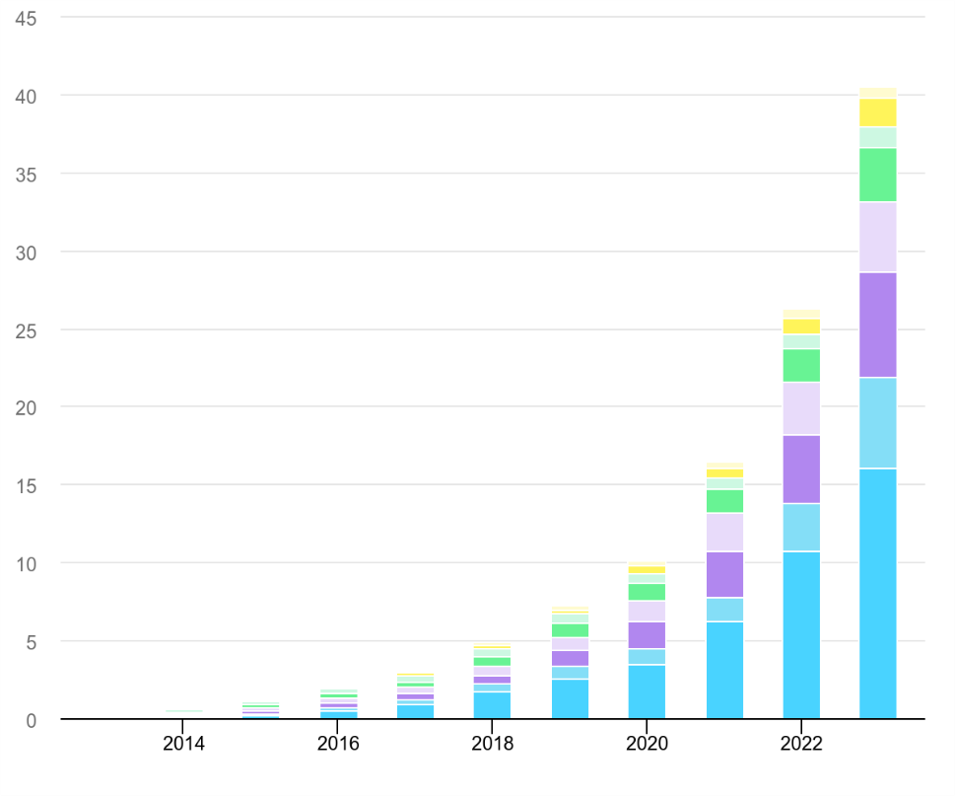
Figure 1: Global Electric Car Sales, 2016 -2024 (IEA, Global EV Outlook 2024)

Malaysia is not left behind in this world transformation. Combining the National Energy Transition Roadmap (NETR) and Low Carbon Mobility Blueprint (LCMB) are aimed at achieving a 15% EV penetration rate of total industry volume in 2030 (Ministry of Economy Malaysia, 2023). To support this target, the Malaysian government has implemented a range of different incentives including full import and excise duty exemptions for battery electric vehicles, alongside targeted investment in national charging network expansion coordinated through the Malaysian Automotive, Robotics and IoT Institute (MARii). Battery Electric Vehicle (BEV) registrations increased by approximately 64% in 2024 alone, underscoring the accelerating pace of domestic adoption (JPJ, 2024). Despite this growth, a structurally important bottleneck that still limits market expansion is the availability, reliability and spatial accessibility of public charging infrastructure. By mid-2024, the Ministry of Investment, Trade and Industry (MITI) counted about 867 public charging points in Selangor and 675 in Kuala Lumpur, which amount to about 1,542 stations across the rest of the Klang Valley. But, as the multi-source data gathering undertaken in this study demonstrates, the spatial distribution of these stations is very narrow in few high-income commercial areas, and the large suburban residential areas register little to no coverage of public charging.
The most repeatedly mentioned psychological barrier to EV adoption in both established and emerging markets in terms of consumer surveys is range anxiety, which is a fear of a vehicle lacking sufficient stored energy to get to its desired destination (Franke and Krems, 2013). Most importantly, range anxiety is not strictly a battery technology issue; it is actually an infrastructure density and spatial assurance issue. A study by Neubauer and Wood (2014) has shown that the density of public charging stations decreases the perceived range anxiety of potential adopters more effectively than an equivalent improvement in battery range, placing strategic spatial placement of charging infrastructure as, perhaps, the most effective lever that could be used by policymakers to speed up the adoption of EVs. This finding is particularly crucial in Malaysia, where most of the country's drivers live in cities. This is because most of the charging infrastructure is in busy commercial areas like shopping mall parking lots and the front yards of high-end hotels. This means that people living in suburbs are systematically left out of the area with confidence benefits that dense charging networks provide. This creates a pattern that keeps suburban residents can't simply switch to EVs without charging infrastructure in their neighborhoods, and business owners don't have any data on how many people use EVs to justify investing in infrastructure in those areas. This study proposes the kind of proactive, data-driven spatial optimization that is needed to break this cycle.

2.2.2 The "Charging Desert" Problem and Spatial Inequity
Although the aggregate charge infrastructure data of large urban areas like the Klang Valley might be satisfactory at the macro scale, a disaggregated space analysis shows a significantly unequal distribution. The current paradigm of infrastructure implementation is almost completely fueled by commercial Return of Investment (ROI) calculations. Commercial developers and Charge Point Operators (CPOs) logically focus on high footfall commercial areas and car parks of shopping malls, upscale hotel forecourts, and up-market condominium complexes where utilization rates are most likely to be greatest and revenue recouping time is shortest. A study by Ermagun and Tian (2024) validated that income exhibits a largely positive correlation with the availability of EV charging stations on a national level, showing that higher-income neighborhoods are always over-represented when it comes to investment in commercial charging infrastructure, and lower-income communities are systematically underserved.
The result of this profit maximization logic is what the literature is now terming as "Charging Deserts" and geographically defined regions with little to no public charging infrastructure even though they contain large residential populations and untapped EV demand. In a study, Roy and Law (2022) built a machine learning model to investigate spatial differences in the location of EV charging stations and discovered that low-income communities with low car ownership had the lowest access to public charging stations, confirming that commercially driven deployment consistently disadvantages suburban residential communities. These deserts are mostly co-located with low-to-middle-income outlying suburban residential zones and communities lack access to their own off-street parking and thus to home charging facilities with high-density public housing estates. The spatial equity analysis of EV charging infrastructure in California by Hsu and Fingerman (2021) found that Black and Hispanic majority neighborhoods were about half as likely as non-majority reference areas to have publicly funded charging stations, which proves the commercial deployment model to be biased against economically vulnerable communities.
In the Malaysian case, the multi-source dataset collected in the given study based on Open Charge Map (OCM), OpenStreetMap (OSM), and Google Maps Places API indicates that the spatial distribution of the 545 distinct EV charging stations found in the Greater Klang Valley is most significantly concentrated around the localities of Wilayah Persekutuan Kuala Lumpur (201 stations) and Petaling In comparison, areas like Klang (5 stations), Gombak (16 stations) and Wilayah Persekutuan Putrajaya (3 stations) that have significant lower-to-middle income residential populations have significantly different results that the infrastructure coverage is much lower. This geographic distribution shows that Charging Desert is not a Western trend but is actively being implemented in Malaysian suburban areas, and it is a direct reflection of the commercial ROI-based implementation pattern found in the international literature. Such an imbalance in the structure is a self-reinforcing cycle with serious consequences of fair EV adoption. Inhabitants of underserved regions will not be able to practically implement EVs because of insufficient charging infrastructure in the neighborhood and this will further kill future utilization projections in the same regions that will deter investment in commercial endeavors. According to Varghese, Menon, and Ermagun's (2024) systematic review of the literature on EV charging infrastructure equity, economic inequality especially those related to income and housing tenure often result in unequal access, and the deployment frameworks currently in use are primarily based on North American and European experiences, leaving large geographical gaps in the evidence of Southeast Asian markets like Malaysia. A change in direction in proactive deployment and equitable weighted geographical optimization is the only option to break free from this self-consolidating cycle. This is the primary goal of the current study.

2.2.3 The Role of Data Analytics and Geospatial Intelligence in Urban Planning
Using computational data analytics in the planning of urban infrastructure is a paradigm shift in methodology as compared to previous ways of doing things. In the past, the location choices of infrastructure were based on manual field surveys, consultative planning workshops, and crude population density maps - processes that were labor-intensive and unable to reflect the dynamism of current mobility trends in urban environments (Goodspeed, 2015). The outcomes were the plans that indicated population distributions as they would be at the time of the survey and not as they would be at the time of infrastructure deployment. This time lag was especially harmful to long term infrastructure projects like EV charging networks, in which the population and mobility situation when the project is deployed can be highly different than when the project was planned.
The growing availability of open geospatial data, such as Points of Interest (POI) registries in OpenStreetMap, vehicle registration records in government open data portals, and high-resolution demographic census data in the Department of Statistics Malaysia (DOSM) have provided unparalleled opportunities to develop empirically based, data-intensive infrastructure planning models (Boeing, 2017). In the context of POI density data, it has become a strong proxy of human dwell-time and mobility demand. Retail stores, food and beverage establishments, offices, educational institutions, and medical facilities are all linked to long durations of vehicle inactivity, hence they make good proxies to the places where EV charging demand will become a reality (Andrenacci et al., 2016). In the context of this study, OSMnx was employed to extract 108,831 categorized POI records across the Greater Klang Valley, spanning 11 demand categories including shopping, residential, workplace, food and beverage, healthcare, education, and transport nodes. This POI data set is the main demand proxy layer on which the Charging Desert Index is calculated and directly operationalizes the data-driven planning paradigm as outlined in the literature.
A review of spatial localization methods to EV charging infrastructure by Pagany, Ramirez Camargo and Dorner (2019) revealed that geographic and demographic variables are consistently the most important site selection aspects in the reviewed literature, with POI-based demand estimation being increasingly favored over more traffic-flow-focused methods due to its reduced data acquisition needs and its higher applicability to low-data settings. This outcome is particularly relevant to the Malaysian situation, where POI density is the most practicable demand proxy for district-level infrastructure planning and detailed real-time traffic data are not publicly accessible. A four-step GIS-based optimal EV charging station siting model in Ankara, Turkey, that integrates fuzzy multi-criteria decision analysis and spatial data layers was demonstrated by Erbaş, Kabk, Oezcean and Cetinkaya (2018) who concluded that POI proximity and population density were the most decisive determinants of charging demand distribution.
Moreover, the combination of unsupervised machine learning algorithms with geospatial frameworks has allowed the detection of latent spatial clusters of demand that otherwise could not be detected using manual planning techniques. Instead of using past transaction rates of charging transactions, unavailable in underserved areas by definition, these methods use existing social economic and behavioral data as demand proxies to estimate where infrastructure must be located. Andrenacci et al. (2016) were the first to use a demand-side model of EV charging station deployment in Rome, Italy, showing that POI-based spatial models can effectively reproduce observed patterns of charging utilization without the need to record past transactions - a key methodological test of proxy-based models in data-poor settings like the suburban charging deserts in Malaysia.

2.2.4 Malaysia's EV Policy Landscape and the Urgency of Spatial Planning
The government of Malaysia has made the adoption of EV a legally binding policy under several policy frameworks that are interconnected. The Low Carbon Mobility Blueprint 20212030 (LCMB), created by the Ministry of Environment and Water, describes a detailed plan of actions to shift the national vehicle fleet to zero-emission technologies in four main areas of strategic focus: vehicle economy and emission reduction, electric mobility adoption, alternative fuel adoption, and modal shift (MGTC, 2021). One of the key quantitative goals set by the LCMB is to have 10,000 public EV charging points across the country by 2025, with 9,000 alternating current (AC) and 1,000 direct current (DC) fast chargers. These targets are supported by the National Energy Transition Roadmap (NETR) (2023), which aligns national energy and transport policy with the nationally determined contributions of Malaysia to the Paris Agreement, and gives a long-term goal of 80% EV adoption and 90% local EV manufacturing by 2050 (Ministry of Economy Malaysia, 2023). By October 2024, Malaysia had deployed about 3,354 charging stations, which are only 33.54 percent of the 2025 goal of 10,000 units. MIDA This significant deficit underscores a serious implementation gap between policy desire and physical infrastructure provision, which can be partly explained by high capital costs to serve the private operators -RM1.5 million to RM2 million per rapid charging installation- lengthy approval process, and lack of demand signals in low-income regions to warrant commercial investment (UNCTAD, 2023).
The Malaysian Automotive, Robotics and IoT Institute (MARii) that organizes the development of EV ecosystems (such as the expansion of the network of national chargers) and the Ministry of Investment, Trade and Industry (MITI), which releases aggregate statistics on infrastructure, are key institutional players. Malaysia Electric Vehicle Charging Network (MEVnet) is a platform established between the Ministry of Housing and Local Government and Malaysian Green Technology and Climate Change Corporation (MGTC) to serve as a coordination mechanism in planning and implementing charging infrastructure to achieve a national accessibility goal (MIDA, 2024). According to official data provided by MITI, there were around 867 registered charging points in Selangor and 675 registered charging points in Kuala Lumpur at the end of the middle of 2024, which provides a total of about 1,542 charging points in Klang Valley. Nevertheless, such aggregate numbers mask important within region spatial inequalities. Most of these installations are clustered in just a few commercial districts, which have high incomes, with large areas of suburban residential severely underserved.
This national policy-ground gap in realizing the policy targets and the equitable distribution of space highlights the urgency of evidence based spatial planning. Unless the 10,000-station target has a quantitative structure of identifying underserved regions, prioritizing infrastructure deployment to those regions, the 10,000-station target will continue to follow the same pattern of commercial-logic concentration that has thus far characterized deployment. The policy background provides a sense of urgency and a point-blank opportunity to the nature of the equity-based spatial optimization framework as suggested in this study.

2.2.5 Alignment with Sustainable Development Goals (SDG 10 and SDG 11)
Two of the United Nations Sustainable Development Goals are inherently connected with the analytical framework of this project. SDG 11 (Sustainable Cities and Communities) promotes inclusive, safe, resilient and sustainable urbanization. Target 11.2 in particular implies the availability of safe, affordable, accessible, and sustainable transport systems to everyone, such as the development of public transport and a special focus on the vulnerable population (United Nations, 2015). This is a direct operational implementation of this target because the implementation of equitably distributed EV charging infrastructure allows extended socioeconomic engagement in the shift to zero-emission urban mobility.
SDG 10 (Reduced Inequalities) is also a key component of the normative framework of this study. Target 10.3 requires the removal of discriminatory policies and practices that reinforce inequality in the access to public goods and services. The current market-based approach to EV infrastructure implementation, i.e. the systematic concentration of resources in high-income regions, is exactly such a structural inequality, albeit, of a commercial rationale, rather than overtly discriminatory policy. Operationalizing the Charging Desert Index (CDI) as a weighted equity measure, expressly including social economic demographic distributions, this study offers a quantitative tool in determining and correcting spatial inequalities, which is directly linked to the accomplishment of SDG 10 and SDG 11.

2.3 Similar Systems

2.3.1 Traditional GIS-Based Heuristic Models
The first formalized computational methods of EV charging station location were based on Geographic Information System (GIS) systems like ArcGIS and QGIS. These approaches used heuristics based on rules and generally a combination of population density layers, road network proximity and land-use zoning classifications to produce candidate site maps. Frade, Ribeiro, Goncalves and Antunes (2011) developed one of the earliest systematic GIS-based EV infrastructure planning models in Lisbon, Portugal, which posed the problem as a capacitated maximum coverage location problem to determine the optimal locations to place the stations, given a constraint on the available budget. The analysis that daytime and nighttime charging demand are estimated using census and employment regressions proved that formal spatial optimization could give meaningfully better results than the intuitive choice of sites location and created the methodological precedent that EV infrastructure placement is a constrained optimization problem.
Erbaş, Kabk, Oezceylan and Cetinkaya (2018) built on this method and incorporated fuzzy multi-criteria decision analysis into a GIS platform to determine the best locations of EV charging stations in Ankara, Turkey. Their four-step approach included population density, accessibility of road networks, and the proximity of electricity grids and POI distributions as weighted spatial layers, and they concluded that POI proximity and population density were the two most significant factors in determining the distribution of charging demand across urban districts.
Yet, GIS heuristic methods are inherently limited, which limits their practical applicability in equity-based planning of infrastructure. To start with, they imminently fixed population censuses and land use maps are not updated on a regular basis and hence any recommendations are based on the past, not the current patterns of human mobility. Second, conventional GIS heuristics are based on a set of preset, manually weighted criteria, which brings a lot of subjectivity into the optimization process and varying analysts with varying weightings on the same spatial layers will come up with radically different station location suggestions. Third, and most importantly to this paper, they do not consider socioeconomic equity as an explicit optimization constraint. The maximization of aggregate coverage model is bound to give priority to large commercial regions as opposed to the sparse residential suburbs and thus recreate but not solve the Charging Desert phenomenon. This trend was validated by Ermagun and Tian (2024) on a national level, as they showed that income has a largely positive correlation with access to EV charging stations, and that higher-income regions continue to receive a disproportionately large share of infrastructure development under both a market-driven and a heuristic guided system of deployment. All these restrictions inspired the research of data-driven machine learning techniques in the future.

2.3.2 Supervised Machine Learning for EV Demand Forecasting
More recent literature has used supervised machine learning models to forecast EV charging demand at a particular place. Such studies generally train regression or classification models, such as Random Forest, XGBoost, and Artificial Neural Networks, using historical records of charging transactions, including time of the day, ambient temperature, local traffic volume, and distance to amenities. Amara-Ouali, Goude, Hamrouche and Bishara (2022) performed a systematic benchmarking analysis of EV charging load and station occupancy models in day-ahead demand forecasting based on open charging session data and compared various supervised machine learning methods, finding the most important problems in the spatial and temporal dependency modelling of charging demand forecasting. Their research established that supervised models have the capability to obtain a high predictive performance in line with the space constraints of the training data and are extremely susceptible to the quality and representativeness of historical charging records.
Using EV charging load data in Shenzhen, China, Liu et al. (2018) used a Random Forest algorithm and exhibited that supervised ensemble models could capture complex non-linear relationships between temporal features and station-level charging demand. Their research also found that the distribution of charging stations within the districts of Shenzhen was highly related to the level of economic development of the district, the highest density of stations was in the richest commercial districts which offers the first empirical evidence in a Chinese context of the same commercial-ROI-driven spatial concentration pattern as that which characterizes the deployment of infrastructure in Malaysia.
Trying to use a supervised model that was trained on regions that are rich in infrastructure to forecast demand in infrastructure-free deserts is a serious mistake of out of distribution generalization, with empirically invalid predictions that may be misleading to policymakers (Géron, 2019). This basic data availability paradox, in that the communities most in need of infrastructure planning are also the communities where no demand data are available, is the core methodological dilemma that the unsupervised, proxy-based approach taken in this study is specifically meant to avoid. The unsupervised, proxy based technique used in this work is clearly designed to avoid this fundamental data availability issue, which is that the communities most in need of infrastructure development are also the communities where demand data are unavailable.

2.3.3 Hybrid Geospatial and Unsupervised Machine Learning Approaches
In the awareness of the shortcomings of purely heuristic and purely supervised methods, there has been an emerging body of research into hybrid frameworks that integrate geospatial data processing with unsupervised or semi-supervised machine learning. Erbaş et al. (2018) proved, based on their multi-criteria GIS model, that spatially distributed and equity-sensitive station recommendations always performed better than the single-criterion optimization models that were based on maximizing aggregate utilization. A systematic literature review of spatial EV charging placement practices by Pagany, Ramirez Camargo and Dorner (2019) found that multi-criteria frameworks using equity weighting of socioeconomic criteria produced more comprehensive results than single-criterion optimization frameworks, and that POI density and demographic weighting were the most important predictors of equitable infrastructure distribution across the studies reviewed.
More recently, hexagonal spatial indexing has been investigated by researchers to enhance the geometric consistency of spatial aggregation. Beresnev (2022) illustrated at the ISPRS Congress that the geometric properties of hexagonal grid-based spatial aggregation have important benefits over square grid systems in urban clustering, such as equal centroid to edge distances, less boundary artefacts, and more consistent cluster assignment when used on dense urban POI data. These properties render hexagonal discretization highly useful as a preprocessing step before an unsupervised clustering algorithm since the isotropic geometry of hexagons means that distance-based computations like the centroid assignment in K-Means are no longer biased by the directional asymmetry found in a rectangular grid system.
Roy and Law (2022) created a machine learning model based on supervised spatial classification to analyze the differences in EV charging station placement, discovering that low-income regions with low car ownership had the least access to public charging stations. Although their methodology was controlled, as opposed to uncontrolled, their study empirically supported the usefulness of socioeconomic and built environment characteristics as predictors of charging infrastructure spatial distribution which give methodological justification to the application of similar sets of features within the framework of the Charging Desert Index in this study. This observation was further supported by a spatial equity analysis of the charging infrastructure of California by Hsu and Fingerman (2021), who confirmed that communities that were economically and demographically disadvantaged were about half as likely to have access to publicly funded charging stations than the higher-income reference groups, and a sense of urgency to prioritize equity weighted optimization frameworks in infrastructure planning. Despite such developments, a gap in research is still apparent and substantial, as indicated by the reviewed literature. The combination of multi-source open data fusion, namely, the JPJ vehicle registration data, DOSM demographic census data, and OSM POI extraction, and H3 hexagonal spatial indexing to produce distortion free aggregation, a composite equity weighted demand index (CDI), and benchmarked unsupervised clustering, between K-Means and DBSCAN, within the single, end-to-end analytical This paper specifically fills this gap.

2.3.4 Comparison of Similar Works
Table below presents a structured comparison of the most methodologically relevant existing studies evaluated against the key dimensions of this research.

Authors (Year) | Study Scope | Method / Algorithm | Data Sources | Key Findings | Limitations | Difference with This Study
Frade et al. (2011) | Lisbon, Portugal | GIS and Maximum Coverage Location Problem | Population density, road network, zoning maps | Identified 12 optimal locations for 100 total stations within budget | Static data, manual criteria weighting, no ML | This study uses dynamic POI proxies and ML clustering, not rule-based heuristics
Erbas et al. (2018) | Ankara, Turkey | GIS and Fuzzy Multi-Criteria Decision Analysis | POI density, road networks, demographic data, electricity grid | More spatially distributed results and population density are the two most decisive siting determinants | No composite equity index, no temporal demand forecasting | This study adds CDI equity weighting and time-series EV registration forecasting
Liu et al. (2018) | Shenzhen, China | Random Forest Regression (Supervised) | Historically charging transaction records, traffic, weather | Strong predictive performance for existing infrastructure zones, station density correlates with district economic level | Requires historical charging data, inapplicable to infrastructure absent deserts | This study uses unsupervised clustering and transaction data required
Pagany et al. (2019) | Systematic Review (Europe) | Multi-criteria GIS, Mixed Methods | Over 40 reviewed studies across European contexts | Equity-weight models consistently outperform single-criterion optimization | Review only; no implemented ML framework or empirical validation | This study implements the equity weighted and unsupervised ML approach recommended
Hsu & Fingerman (2021) | California, USA | Spatial Equity Analysis and regression | Charging station registries and race/income data | Disadvantaged community’s half as likely to access publicly funded charging stations | Access to publicly funded charging stations is half as common in disadvantaged areas. | This work uses the CDI and clustering pipeline to expand equity analysis into prescriptive spatial optimization.
Table 1: Similar works of EV Charging Infrastructure Planning
The comparison shown in Table above indicates that although the methodology's individual components have been validated independently in the literature, no previous research has integrated the entire pipeline to multi source open data fusion, H3 hexagonal indexing, the Charging Desert Index, and benchmarked K-Means versus DBSCAN clustering in a Malaysian Klang Valley context with clear equity weighting. While every evaluated paper offers a limited methodological solution, no one fully solves the issue of equity-weighted, data-limited EV infrastructure optimization in an emerging-market context in Southeast Asia.

2.3.5 Research Gap
The research gap that underlies this study can be formulated precisely in three dimensions that are interrelated. To start with, data availability wise, the current supervised machine learning models necessitate historical charge transaction data that is definitionally inaccessible in underserved regions making them structurally not applicable to the Charging Desert problem. Second, methodologically, the classic GIS heuristic models use fixed, manually weighted attributes that not only fail to generate moving human mobility patterns but also have no explicit optimization constraint on socioeconomic equity, inescapably repeating the commercial deployment biases to which they are meant to remedy. Third, geographically, both independent studies by Pagany et al. (2019) and Varghese, Menon and Ermagun (2024) noted that the current literature is dominated by North American and European infrastructure contexts, and there is significant geographical gaps in the evidence found in Southeast Asian markets where EV adoption is gaining traction at a rapid rate under different socioeconomic and spatial conditions. The suggested CDI paradigm, operationalized by H3 hexagonal spatial indexing, multi-source open data fusion, and benchmarked unsupervised K-Means and DBSCAN clustering directly tackles all three aspects of this gap identified. By replacing insufficient transaction data for POI density, demographic distributions, and time-series EV registration forecasts, the system resolves the data availability issue. It makes equity a primary optimization goal by quantitatively incorporating income-weight equity scoring in the CDI formula, moving equity to a post-hoc factor. It, and by applying this pipeline to the Greater Klang Valley, forms the first rigorously validated, equity-weighted geospatial optimization framework of EV charging infrastructure in the Malaysian context - extending the frontier of evidence-based infrastructure planning to a high-growth Southeast Asian market that the literature has so far not explored. By quantitatively adding income weighted equity score to the CDI algorithm, it shifts equity to a post-hoc consideration and makes equity a main optimization target. By applying this pipeline to the Greater Klang Valley, it generates the first highly validated, equity-weighted geospatial optimization framework of EV charging infrastructure in the Malaysian context and expanding the limits of evidence-based infrastructure planning to a rapidly growing Southeast Asian market that has not yet been covered in research.

2.4 Technical Research

2.4.1 Hardware and Software Identification and Justification
This section determines the physical, and software needs to develop the geospatial optimization and demand forecasting model suggested in this study. The pipeline of data analysis also includes processing a large amount of spatial and tabular data, such as 108,831 POI records collected in OpenStreetMap, multi-source EV charging stations data, district-level demographic census data provided by DOSM, and monthly vehicle registration time-series by JPJ as well as computationally intensive task, including H3 hexagonal spatial indexing, iterative K-Means and Memory-wise, a minimum of 16 GB RAM is needed to load all datasets at once when performing GeoPandas spatial join operations and machine learning model inference to avoid disk-based memory swapping. To store, one will need at least a Solid-State Drive (SSD) with a storage capacity of 512 GB or more to be able to read and write large CSV files, shapefile, and geospatial output files at high speeds.
It requires a multi-core processor that has adequate clock speed to execute parallelized implementations of clustering algorithms in Scikit-learn. Even though the existing pipeline does not need any GPU acceleration, since all clustering and forecasting algorithms in this study are CPU-intensive, the included dedicated GPU on the development machine is an option to be extended in the future, in case the framework will be extended to use deep learning-based spatial demand models.
Table below summarizes the hardware specifications of the development machine used in this project:

Component | Specification
Processor | Intel Core i5-12500, 6 Cores 3.00 GHz (Boost up to 4.60 GHz)
RAM | 16 GB DDR5
Storage | 512 GB Solid State Drive (SSD)
GPU | NVIDIA GeForce RTX 3050 (4 GB GDDR6)
Table 2: Hardware Specifications Used for Project Development

2.4.2 Integrated Development Environment (IDE)
The IDE that will be used in the project is the Visual Studio Code (VS Code) along with the Jupyter Notebook extension. VS Code is a free, open-source code editor created by Microsoft to support many different programming languages, along with Git version control, a Python linter, and an interactive terminal, all in one interface. Jupyter Notebook extension enables every step of the data pipeline (such as data ingestion, spatial indexing, CDI computation, and clustering) to be run as a single notebook cell, an interface that is particularly appropriate in the iterative process of data analytics development. The in-built notebook experience also makes Folium interactive maps and Matplotlib visualization inline, allowing visual feedback to be instant in exploration data analysis. Also, VS Code will facilitate Python virtual environments, where the project dependencies can be separated into their own environment to ensure portability among various machines.

2.4.3 Libraries and Tools
The main programming language that will be used in this project is Python 3.11. Python was selected because it has a wide range of geospatial analysis, machine learning, and data visualization features with a broad ecosystem of open-source libraries. It is popular in both academic and industry data science settings and has the most extensive collection of tools directly applicable to the needs of this project.
- All tabular data manipulation and preprocessing, such as loading, cleaning and merging of the multiple datasets utilized in the project into a single analytical database, are performed with panda.

- GeoPandas adds geospatial features to Pandas, allowing spatial joins, coordinate reference system conversions, and reading and writing shapefile files needed to manipulate the Klang Valley boundary and station location data.

- OSMnx is applied to retrieve the POI data of the OpenStreetMap data with the help of polygon-based API queries, which provides 108,831 categorised POI records spread across 11 demand categories which form the main proxy of charging demand used in the Charging Desert Index.

- H3-py is the Python binding to the H3 Hexagonal Hierarchical Geospatial Indexing System of Uber. It is employed to discretise the study area into hexagonal cells at Resolution 8 to spatial aggregate all POI, demographic and station data without distortions before clustering.

- Scikit-learn also has the K-Means and DBSCAN implementation of the clustering algorithms utilized in this project, the Silhouette Score and Davies-Bouldin Index functions to measure and compare the quality of the results of the clustering output.

- Interactive Leaflet.js-based choropleth maps and cluster visualisation layers are generated with Folium, and the final geospatial planning dashboard is exported as a self-contained HTML file that can be viewed in any web browser.

- Statistical exploratory data analysis such as the creation of distribution plots, correlation heatmap, and elbow method charts to select K-Means cluster count are done using Matplotlib and Seaborn.

- Prophet is the open-source time-series forecasting library of Meta that is utilized to predict the number of future district-level EV registrations up to 2030. It was chosen due to its capability to deal with non-linear S-shaped technology adoption growth curves, seasonal trends and trend change points that describe EV adoption data.

- The ARIMA model implementation to compare with Prophet and the Augmented Dickey-Fuller stationarity test to be applied during the preprocessing of time-series can be found in Stats models.

- Requests receive the HTTP requests to the Open Charge Map REST API and the Malaysian Open Data Portal as a part of the data collection stage of the project.

2.4.4 Operation System
This project is operating under the Windows 11 (64-bit) by Microsoft operating system. Windows 11 was chosen due to compatibility with hardware and familiarity with the development. It is user-friendly and clean and provides all the tools and libraries needed in this project, such as Python 3.11, Visual Studio Code, and all the geospatial and machine learning libraries that are outlined in Section 2.4.3. Every Python library in this project is completely cross-platform, and no operating system specific limitations were experienced in the development process. Windows 11 also has the Windows Subsystem for Linux 2 (WSL2) allowing access to Linux command-line tools when necessary to do spatial data processing work without installing separate operating systems.

2.5 Summary
This chapter has formed the multi-layered scholarly and technical basis of the research design of this study. The domain review established that although EV uptake is increasing at a rapid rate internationally and in Malaysia, the spatially unfair distribution of public charging infrastructure due to the short-term commercial ROI rational is creating sustained Charging Deserts in lower to middle-income suburban regions throughout the Klang Valley. This institutional imbalance is a direct obstacle to the national agenda of EV adoption and violates the equity imperative of SDG 10 (Reduced Inequalities) and sustainable urbanization goals of SDG 11 (Sustainable Cities and Communities).
The existing GIS-based heuristic models are fixed and subjective weighted, while machine learning supervised ones require access to historical data on charging transactions, which is impossible in the charging deserts of infrastructures. This methodological gap was found to be clear and enduring in literature. This basic data availability paradox, that the neediest communities are the ones that do not have any demand information to plan infrastructure, is the core issue that no current framework has sufficiently tackled in the Malaysian setting.
The technical review showed that the integration of the H3 Hexagonal Grid of distortion free spatial pre-processing at Uber, K-Means clustering of demand gravity centers, DBSCAN of naturally density clusters and Prophet/ARIMA of demand forecasting at the district level, represents the most scientifically rigorous approach to the availability of proxy-based, equity-weighted EV infrastructure optimization. Combining the Charging Desert Index as a composite mechanism of demand and equity scoring, which is measured with the Silhouette Score and Davies-Bouldin Index, guarantees that the outputs of the framework will be both mathematically justified and practical to the urban planners and CPOs. These analytical principles are the direct input in data engineering and modelling pipeline in the next methodology chapter.

Chapter 3: Methodology

3.1 Introduction
This chapter describes the approach that was taken towards the design of the geospatial optimization and demand forecasting model to ensure fair Electric Vehicle (EV) charging infrastructure in the Greater Klang Valley. The methodology offers organized, evidence-based data gathering, pre-processing, spatial modelling, and analysis, which would allow the attainment of all four research aims in a systematic and reproducible manner. Since this project is data-driven, i.e., the combination of five open-source datasets, the construction of an original composite index, and the evaluation of two unsupervised machine learning algorithms, the formal data mining process model is required to regulate the analytical process and provide a level of methodological rigor.
In this project, the CRISP-DM (Cross-Industry Standard Process for Data Mining) has been chosen as the methodology to follow. CRISP-DM is both a well-established standard in academic literature and industry practice as the data analytics project structure, and its industry-neutral, iterative design facilitates its direct application to the geospatial machine learning pipeline suggested in the current research. This chapter defends the selection of the CRISP-DM as opposed to other methodologies, and explains in detail the phases, activities, techniques, and processes used during each stage of the project lifecycle.

3.2 Methodology

3.2.1 Introduction to CRISP-DM Methodology
CRISP-DM (Cross-Industry Standard Process of Data Mining) is a broad and generalized process model that splits the data mining lifecycle into six iterative steps: Business Understanding, Data Understanding, Data Preparation, Modelling, Evaluation and Deployment (Wirth and Hipp, 2000). The framework was first created in 1996 with a consortium of DaimlerChrysler, SPSS Inc., and NCR Systems Engineering and published formally in 2000 and has since then become the most popular in the data mining and data analytics community (Chapman et al., 2000).
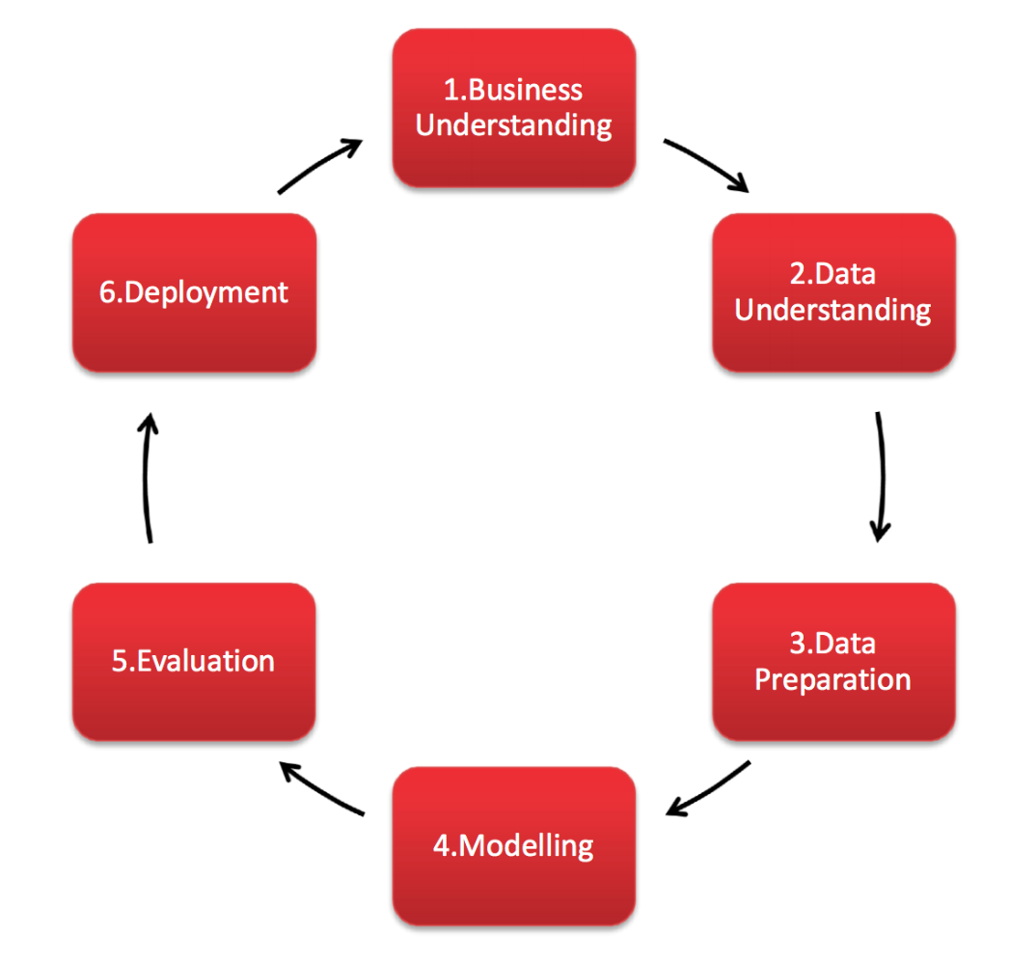
Figure 2: CRISP-DM Diagram

Another distinguishing feature of CRISP-DM is that it is non-linear and iterative. Contrary to the sequential development models, CRISP-MM clearly recognizes the fact that the real-world data analytics project needs to move in a back-and-forth direction depending on the success of each phase (Wirth and Hipp, 2000). As an example, the results of the Data Understanding stage, like the identification of the missing district labels within the EV station dataset, might require retaking to the Data Collection stage to enrich the data and then continue moving to the preprocessing stage. This flexibility is required to be iterative since this kind of project requires the quality and structure of various open-source datasets to be unknown until collection occurs.
Schroer, Kruse and Gomez (2021) performed a systematic literature review of the literature using CRISP-DM in IEEE, ScienceDirect, and ACM databases and found that CRISP-DM is still the standard of data mining process models over 20 years after its debut. In their review, they established that the most frequently mentioned reasons of choosing CRISP-DM included, its ordered and trustworthy procedure, convenience, and its popularity in the academic and industrial worlds - all of which are specifically applicable to the specifics of the present project.

3.2.2 Methodology choice and justification
CRISP-DM was chosen to be used as the guiding methodology in this project among two main alternative frameworks KDD (Knowledge Discovery in Databases) and SEMMA (Sample, Explore, Modify, Model, Assess) due to a critical analysis of their applicability to particularities of the given project.
KDD, which was suggested by Fayyad, Piatetsky-Shapiro and Smyth (1996) is a technically sound model of processes that focuses on transforming raw data into valuable knowledge. Although KDD is well-established academically, it is more of a theoretical framework, which offers minimal practical advice to project planning, stakeholder communication, and deployment, which are essential to this project based on the target audience, namely urban planners and Charge Point Operators (CPOs). CRISP-DM specifically focuses on these practical dimensions with its Business Understanding and Deployment phases, which KDD does not discuss in such detail (Chapman et al., 2000).
SEMMA is a process created by SAS Institute, a very narrow methodology that starts at sampling of data and skips entirely the first step of defining problems and business context. According to Schroer et al. (2021) in their systematic review, the popularity of SEMMA decreased greatly over recent years and is not typically viewed as a holistic approach to project management. In a project, the main aim of which is directly related to a real-world policy issue, namely, the fair distribution of EV charging infrastructure in accordance with SDG 10 and SDG 11, the lack of the Business Understanding phase would essentially hamper the project stability in terms of its capacity to stay grounded in its practical policy goals.
CRISP-DM on the other hand commences with a formal Business Understanding phase which ensures that all the other analytical decisions made are based on the stated research problem and the actual goals in the real world (Wirth and Hipp, 2000). Its iterative structure fits the multi-source heterogeneous characteristics of datasets used in this project where preprocessing choices, like the 60% dealer registration weighting adjustment made to the JPJ vehicle registration data, were discovered during iterative data quality evaluations, rather than anticipated upfront. Moreover, the fact that CRISP-DM explicitly has a Deployment phase corresponds directly with the goal of the current project of creating an actionable geospatial dashboard that can be used by urban planners and CPOs as a decision support tool, a type of output that is not quantified at all in purely technical frameworks like KDD.
On these grounds, CRISP-DM is the most suitable, academically and practically the most adequate methodology to be applied in this project.

3.2.3 Phases of CRISP-DM
The CRISP-DM framework organizes the project into six phases, each with defined activities, techniques, and outputs directly mapped to the objectives of this study. The phases are described below.
Phase 1 — Business Understanding
Business Understanding phase entails presenting the research problem in its practical policy setting, defining the project goals and transforming the goals into the data mining objectives (Chapman et al., 2000). The business issue in this paper is that the spatial concentration of EV charging facilities in the Greater Klang Valley is unequal due to the profit-maximizing logic of commercial deployment, resulting in Charging Deserts in residential suburban low to middle-income neighborhoods. The main data mining objective based on this business issue is the creation of the Charging Desert Index (CDI) it is a composite equity-based demand measure - and its operationalization using unsupervised spatial clustering to determine the best places to roll out charging stations in the future. The phase also defines the alignment of project outcomes to SDG 10 (Reduced Inequalities) and SDG 11 (Sustainable Cities and Communities) so that the analytical pipeline can be geared towards equitable and inclusive infrastructure planning at all later stages.
Phase 2 — Data Understanding
The Data Understanding stage is where all the appropriate datasets are gathered, analyzed regarding their format and the contents and evaluated regarding completeness, consistency and utility (Wirth and Hipp, 2000). In this project, 5 open-source datasets were obtained: JPJ vehicle registration data (data.gov.my) on data.gov.my, district population and household income data (DOSM OpenDOSM) on data.gov.my, Point of Interest (POI) data obtained through OpenStreetMap by using the OSMnx (108,831 records in 11 categories), and a combined dataset of Early analysis of these datasets uncovered a number of data quality challenges, such as missing district labels in some of the Google Maps station data, spatial duplication between the sources and geographic distortion in the JPJ data because of vehicles registered by dealers, all of which were later resolved during the Data Preparation step. Exploratory Data Analysis (EDA) was performed to appreciate the spatial distribution of the available stations, the demography of every district, and the demand categories of POI in the study area.
Phase 3 — Data Preparation
Data Preparation involves all the pre-processing processes necessary to convert the raw datasets collected into a clean, integrated and a clean analytically prepared format that can be modelled (Chapman et al., 2000). It is generally the most arduous stage of any CRISP-DM project, and this research is not an exception due to the multi-source and heterogeneous character of the datasets considered. This stage involves main tasks such as dealing with missing values in the station dataset, deduplicating entries across OCM, OSM, and Google Maps sources with a spatial proximity threshold of 50 metres, adjusting the 60 per cent dealer registration weighting to the JPJ dataset to correct the spatial distortion due to Rakan dealer registration, normalizing demographic and POI variables to a common scale, and aggregating all spatial data Charging Desert Index is calculated at this point based on a weighted average demand score and the current EV infrastructure coverage of each hexagonal cell.
Phase 4 — Modelling
The Modelling stage consists of choosing and running the most suitable analytical algorithms on the ready-to-use dataset and adjusting their parameters to have the meaningful and interpretable results (Wirth and Hipp, 2000). In this study, two complementary modelling streams are taken simultaneously. To achieve spatial clustering, K-Means and DBSCAN are used to the hexagon-aggregated CDI scores and spatial coordinates to determine the best location of charging stations within the Greater Klang Valley. K-Means is used to find the natural density centers of mathematical demand gravity and DBSCAN finds the natural density centers organically and isolates the uninhabited noise centers like conservation forests and water bodies. Elbow Method is used to determine the best K value of K-Means. In demand forecasting, Prophet and ARIMA time series models are used on the JPJ vehicle registration time-series to predict the district EV registration volumes up to 2030 to give the demand dimension to the spatial clustering analysis.
Phase 5 — Evaluation
The Evaluation stage identifies whether the modelling deliverables meet the initial business objectives and data mining targets satisfactorily and ascertains whether the project is fit to be deployed to deployment (Chapman et al., 2000). Two internal cluster validation measures (Silhouette Score, Rousseeuw, 1987 and Davies-Bouldin Index, Davies and Bouldin, 1979) are used in this research to assess the spatial clustering outputs. These metrics are employed to assess the quality and spatial relevance of the K-Means and DBSCAN clustering results and to choose the algorithm that generates the most geographically valid and fair station location suggestions. Time-series forecasting models are compared to one another in terms of Mean Absolute Percentage Error (MAPE) to check on a held-out validation window which of Prophet or ARIMA generates more accurate district-level demand forecasts.
Phase 6 — Deployment
The Deployment phase then converts the modelling outputs into a form that can be utilized and consumed by the target end users namely the urban planners, government transport policymakers and commercial Charge Point Operators (Chapman et al., 2000). Folium is used to create an interactive geospatial dashboard to visualize the Charging Desert Index heatmap, optimal cluster centers, and priority expansion areas throughout the Greater Klang Valley. The dashboard is published as a separate HTML file, which can be viewed in any web browser without having to install any further software, such that its results can be effectively applied by non-technical stakeholders in the context of urban planning and infrastructure decision-making.

3.3 Data Collection
In this section, we name the datasets used in this project, their contents and the context of how they will be used in the research, and their sources. Data collection followed the CRISP-DM approach, with the data requirements that were defined in the Business Understanding phase applied, namely the requirement of spatial, demographic, and infrastructure data that combined allow the calculation of the Charging Desert Index and the creation of the time-series demand forecasting model. The datasets presented in this project are all openly available in government open data portals and existing geospatial platforms, which means that they are transparent, reproducible, and are not in violation of the requirements of data ethics.
Five datasets were gathered which included Vehicle registration data, district-level demographic and income data, Point of Interest demand proxies, and multi-source EV charging station data. All the datasets collected are listed in a tabular form in table below

No. | Dataset Name | Source | Description | Format | Link
1 | JPJ Vehicle Registration Dataset | Road Transport Department (JPJ) via data.gov.my | Car registration Transactions from 2000 onwards. Filtered for fuel_type = electric to extract BEV registrations. Used for time-series demand forecasting. | CSV | https://data.gov.my/data-catalogue/registration_transactions_car
2 | District Population Dataset | Department of Statistics Malaysia (DOSM) via OpenDOSM | District-level population counts for all districts within the Greater Klang Valley study area. Used as a demographic demand weight in the Charging Desert Index. | CSV | https://data.gov.my/data-catalogue/population_district?state=w-p-kuala-lumpur&district=batu-pahat&visual=tablelumpur&district=batu-pahat&visual=table
3 | District Household Income Dataset | Department of Statistics Malaysia (DOSM) via OpenDOSM | District-level median household income data. Used as a socioeconomic equity weighting variable in the Charging Desert Index to identify lower-income areas that are structurally underserved. | CSV | https://data.gov.my/data-catalogue/hh_income_district?date=2022-01-01&visual=table
4 | Point of Interest (POI) Demand Proxy Dataset | OpenStreetMap (OSM) via OSMnx Python library | 108,831 categorised POI records extracted across the Greater Klang Valley boundary, spanning 11 demand categories including retail, food and beverage, education, healthcare, workplace, and transport nodes. Used as the primary charging demand proxy layer. | GeoDataFrame (CSV + GeoJSON) | https://www.openstreetmap.org
5 | Fused EV Charging Station Dataset | Open Charge Map (OCM), OpenStreetMap (OSM), Google Maps Places API | 545 unique public EV charging stations compiled and deduplicated from three sources: OCM (288 records), OSM (52 records), and Google Maps Places API (205 records). Represents the existing infrastructure coverage layer used in the CDI computation. | CSV | API Keys
Table 3: Summary of Datasets Collected for the Project

3.3.1 JPJ Car Registration Dataset
It was discovered that there was one major data quality problem when first exploring this dataset. The JPJ Car Registration Transactions dataset has a state field that either holds one of the 16 states of Malaysia or the Rakan Niaga category which means vehicles registered via an official JPJ portal, usually an authorized car dealer on behalf of the purchaser. The field, according to the official data.gov.my catalogue documentation, is not linked to the actual residential location of the car owner, implying that vehicles registered with the Rakan Niaga have no valid geographic designation based on the home state of the buyer (data.gov.my, 2024).
It was discovered that there was one major data quality problem when first exploring this dataset. The JPJ Car Registration Transactions dataset has a state field that either holds one of the 16 states of Malaysia or the Rakan Niaga category which means vehicles registered via an official JPJ portal, usually an authorized car dealer on behalf of the purchaser. The field, according to the official data.gov.my catalogue documentation, is not linked to the actual residential location of the car owner, implying that vehicles registered with the Rakan Niaga have no valid geographic designation based on the home state of the buyer (data.gov.my, 2024). This poses a problem of spatial distortion to this study. Because Rakan Niaga registrations indicate the registered business address of the dealer, but not the residential address of the buyer, the uncoded geographic distribution of EV registrations in the data set does not represent the true geographic distribution of where the owners of the vehicles live. To counter this, a 60% weighting correction was used to redistribute Rakan Niaga-registered EV entries into the Klang Valley study area as a sensible geographic proxy. The rationale behind this change is the fact that Kuala Lumpur and Selangor alone represent about 60% of national vehicle sales, as the two areas have developed a high concentration of authorized dealerships, population concentration, and higher household income levels (Ken Research, 2021; Narwat, 2023). This correction is reported as a methodological assumption and admitted as a limitation of the study in Chapter 4.

3.3.2 DOSM Population Dataset
The second data source is the District Population Dataset, which was taken by the Department of Statistics Malaysia (DOSM) using the open data portal called OpenDOSM at the web address open.dosm.gov.my. The dataset will give the population counts at the administrative district level of all the administrative districts in the study area of Greater Klang Valley, i.e., Wilayah Persekutuan Kuala Lumpur, Wilayah Persekutuan Putrajaya, and all seven Selangor districts that are within the study area. The data is in the CSV format. The Charging Desert Index also considers the population density as a demanding variable, indicating how many potential EV users there are in each hexagonal cell within the area of study.

3.3.3 DOSM Household Income Dataset
The third data is the District Household Income Dataset which was also sourced at the Department of Statistics Malaysia (DOSM) via the OpenDOSM website at https://open.dosm.gov.my. The dataset contains the median household income at the district level values of the same administrative districts as those in the population dataset and is in CSV format. The socioeconomic equity weighing variable that is used in the Charging Desert Index is the median household income, which determines the low-income districts in which the commercial deployment model underinvested in the public charging infrastructure. This variable is directly operationalized to reflect the equity aspect of the CDI and is relevant to the project in respect of SDG 10 (Reduced Inequalities).

3.3.4 OpenStreetMap Point of Interest Dataset
The fourth data is the Point of Interest (POI) Demand Proxy Dataset, which is obtained using the OSMnx Python library by extracting the data in OpenStreetMap (OSM). OSMnx allows API queries based on polygons to fetch all tagged amenity, retail, leisure, and transport features within a given geographic area (Boeing, 2017). A total of 108,831 POI records were obtained within the Greater Klang Valley area which covers 11 demand categories: retail and shopping, food and beverage, education, healthcare, workplace and office, residential, transport nodes, recreational and leisure, religious, financial services and accommodation. The resulting data is saved in Geodata Frame format of both CSV and GeoJSON output and the original source location is available at https://www.openstreetmap.org.
This dataset is the main layer of demand proxy of the Charging Desert Index, which operationalizes the well-tested methodological principle that POI density is a credible surrogate of human dwell-time and vehicle inactivity periods, the conditions in which EV charging demand is most apt to become a reality (Andrenacci et al., 2016). Using the OpenStreetMap data is supported by practical and academic reasons. OpenStreetMap is a public knowledge base of geospatial data used worldwide as a trustworthy source of data to conduct an urban POI analysis in multiple peer-reviewed articles (Boeing, 2017). Being open-licensed and with the OSMnx extraction library available, it is the most open and reproducible source of high-resolution POI data in the Malaysian context, where no similar proprietary commercial dataset is publicly available.

3.3.5 Fused EV Charging Station Dataset
The fifth data set is the Fused EV Charging Station Dataset, which has been created based on three separate open-source services namely OpenCharge Map (OCM), OpenStreet Map (OSM), and Google Maps Places API. The Open Charge Map, which is available at https://openchargemap.org, added 288 station entries. OpenStreetMap, found at the address of https:/openstreetmap.org, added 52 records. The records added by Google Maps Places API are available on the Google Cloud developer platform at https://developers.google.com/maps and contributed 205 records. The three sources were merged into one unified dataset with a multi-stage spatial deduplication pipeline, resulting in a total of 545 unique stations with cross-source duplicate entries filtered out with a 50-metre spatial proximity threshold. The resulting merged dataset is saved in the form of CSV.
The rationale that informed the choice to merge several sources as opposed to depending on one platform was the fact that no single source has extensive coverage of the charging infrastructure in the Klang Valley. Cross-referencing in the data collection process showed that a large percentage of the stations that showed up in Google Maps did not show up in OCM and vice versa meaning that the single-source methodology would have systematically underestimated the actual installed base. The merged dataset of 545 stations is the most comprehensive publicly available dataset of EV charging infrastructure in the Greater Klang Valley as at mid-2024, and the current coverage layer of the infrastructure in the CDI computation, which calculates the extent to which each hexagonal cell is already covered by public charging and what is the remaining unmet demand that the clustering model aims to satisfy.

3.4 Data Preprocessing & Data Understanding

3.4.1 Data Preprocessing
This section describes the data pre-processing steps that were used on each of the five datasets that have been used in this research. The datasets include the JPJ Car Registration Dataset between 2020 and 2026, the DOSM District Household Income Dataset, the DOSM District Population Dataset, the OpenStreetMap Point of Interest Demand Proxy Dataset, and the Fused EV Charging Station Dataset that is a combination of three sources such as Open Charge Map, OpenStreetMap, and Google All datasets were subjected to a sequence of pre-processing operations to improve the quality of data, including missing values, inconsistent naming conventions of districts, and irrelevant attributes, making all five datasets clean and uniform, and capable of being integrated into the Charging Desert Index computation pipeline in the next modelling step.

3.4.1.1 Car Registration Transactions
The JPJ Car Registration Dataset pre-processing started with loading and joining seven separate CSV files (one per year 2020-2026) into a single unified dataframe. This was done through a for loop which loops through each year, reads the corresponding CSV file via the pd.read_csv() method of the Pandas library, adds a year column to each file, and adds the individual dataframes to a list. The pd.concat() method was then used to combine all the seven dataframes into a single dataset. In Figure 3, the combined data yielded a total of 4,578,675 records in eight columns, such as date reg, type, maker, color, fuel, state and year.
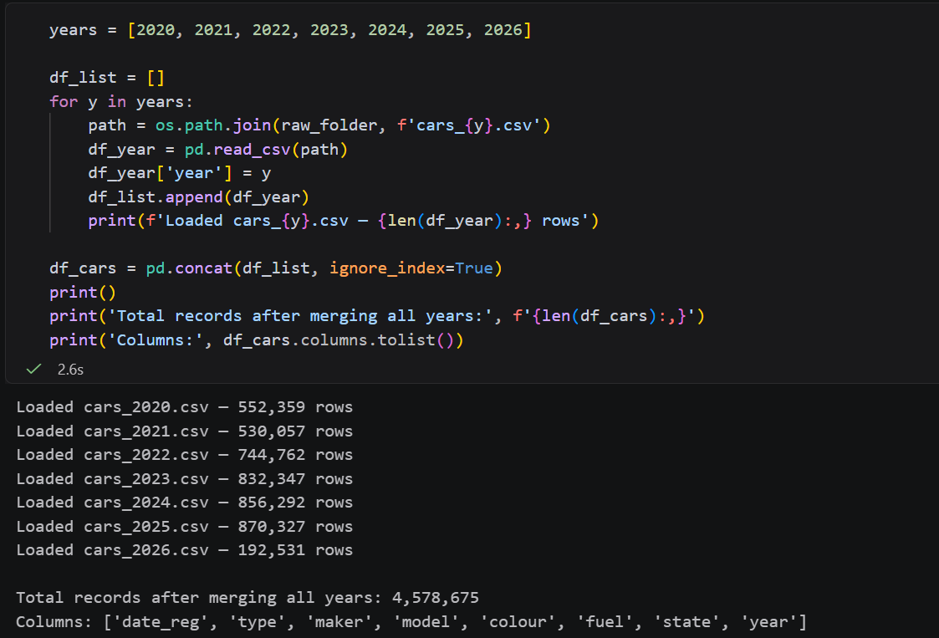
Figure 3: 7 files loaded and total 4,578,675 rows

After the merger, the dataset was reduced to those records whose fuel column has the value of electric, through a Boolean mask statement df_cars[df-cars[fuel] = electric]. This narrowed down the data to 97,951 Battery Electric Vehicle (BEV) registration records. EV registrations have a steep upward trend as shown in Figure X with only 71 registrations in 2020, and 44,813 in 2025, indicating the rising rate of EV adoption in Malaysia.
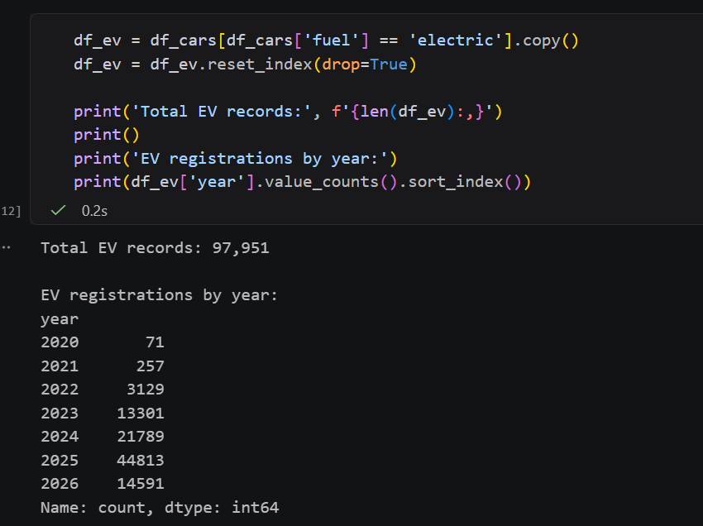
Figure 4: showing 97,951 EV records and year breakdown
An inspection of a missing value with the df_ev.isnull().sum() proved that no null values were found in any of the eight columns, which means that the dataset is structurally complete and does not need any imputation at this point. The date reg column was verified as an object type of data, and this had to be converted into the datatype of a date time in a subsequent step.
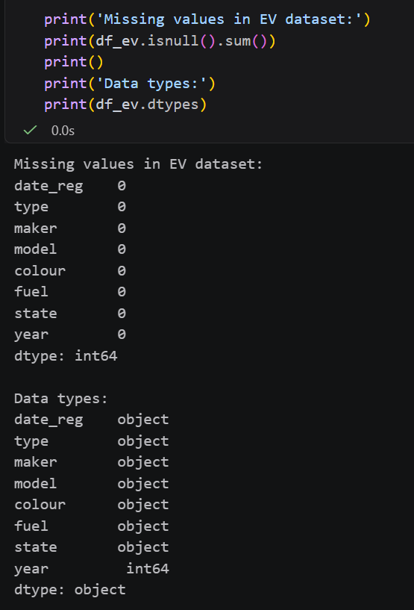
Figure 5: showing all zeroes in null check
The state field was then found to have a critical data quality issue. A proportion analysis of the Rakan Niaga records, done by iterating the year and calculating the ratio of Rakan Niaga records to total EV records, showed that 72,502 of 97,951 EV records, or 74.0 percent of the total EV records, bore the Rakan Niaga designation and not a legitimate Malaysian state name. As Figure X demonstrates, this ratio has been increasing dramatically each year, with the number of years increasing by 57.7% in 2020 and 84.3% in 2026. Based on the official data.gov.my catalogue documentation, Rakan Niaga entries involve vehicles being registered via approved JPJ dealer portals and which have no valid geographic attribution to the residential state of the buyer (data.gov.my, 2024). Keeping these records uncorrected will bring in a high level of spatial distortion into the time-series demand forecasting model.
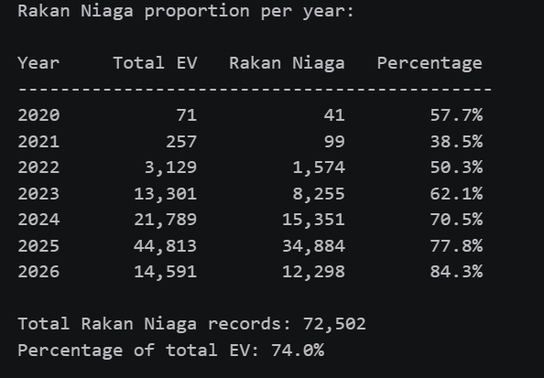
Figure 6: Rakan Niaga Proportion table
To correct this space distortion, the entire Rakan Niaga EV records were 60% redistributed, as it was documented that Kuala Lumpur and Selangor have a combined proportion of about 60 percent of all vehicle sales in the country (Ken Research, 2021; Narwat, 2023). The redistribution was done in two phases. Initially, proportional weights of each state of KV were obtained based on actual KV registrations using value counts(normalize=True), which resulted in weights of 74.7 percent W.P. Kuala Lumpur, 25.3 percent Selangor and 0.006 percent W.P. Putrajaya. Second, 60 percent of the Rakan Niaga records were sampled with a fixed random number of 42 to ensure good reproducibility (df_rn.sample) with 43,501 records, and state labels were randomly assigned proportionally using np.random.choice). As Figure X indicates, the redistributed records were issued to W.P. Kuala Lumpur and Selangor respectively as 32,568 and 10,933 records respectively.

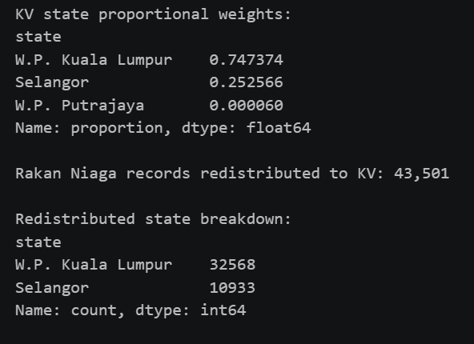
Figure 7: KV weights and breakdown
The 43,501 records which were redistributed were then added to the 16,562 true KV EV records using pd.concat, and a final combined KV EV dataset of 60,063 records was obtained. The final states distribution as indicated in Figure X will be 44,946 to W.P. Kuala Lumpur, 15,116 to Selangor and 1 to W.P. Putrajaya.
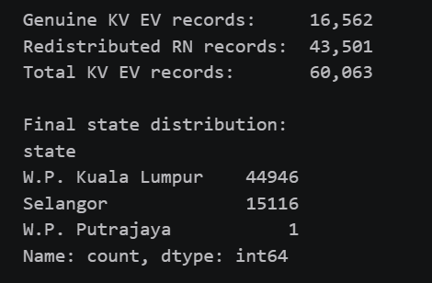
Figure 8: showing 60,063 total and state breakdown
Date reg column was then transformed into object to the datetime format by using pd.to_datetime method whereby the year and month characteristics were extracted by using.dt.year and.dt.month accessor respectively. The column of year_month period was also calculated with the help of .dt.to_period(M) to facilitate the monthly level time-series aggregation in the forecasting phase. Unimportant columns to the geospatial and forecasting analysis, i.e., type, maker, model and color, were then dropped with the help of df.drop() command. The cleaned final dataset has 60,063 records in 6 columns as shown in Figure 8.
Figure 9 summarizes that the raw dataset of 4578675 records was reduced to a focused KV EV time-series dataset of 60,063 records by the pre-processing pipeline, and that the Rakan Niaga spatial distortion was mitigated by redistributing the KV EV time-series proportionally. The processed data were written to the processed data directory as jpj_kv_ev_clean.csv.
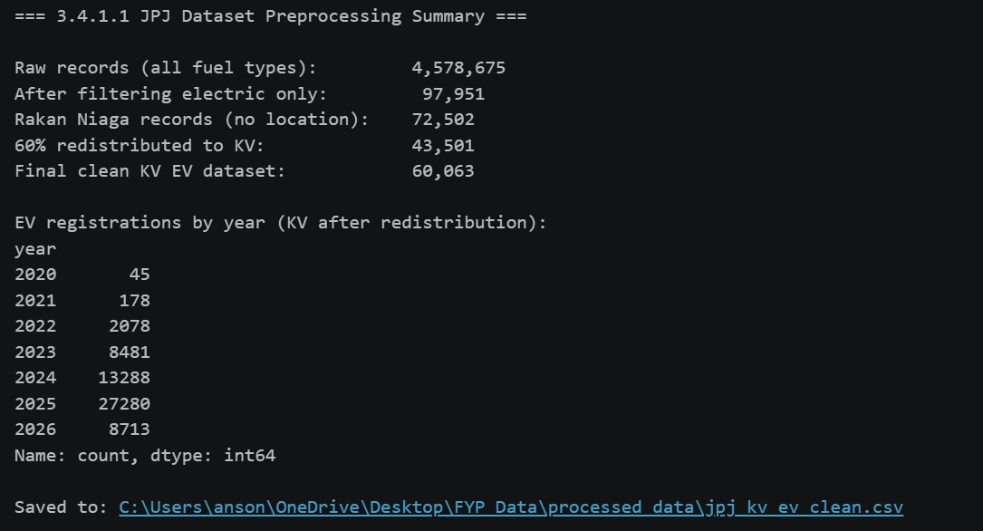
Figure 9: summary of cars dataset

3.4.1.2 Household Income Dataset
The Household Income Dataset was loaded from the raw_data directory using pd.read_csv(). As shown in Figure 10, the dataset contains 318 records across 5 columns, namely state, district, date, income_mean, and income_median, covering all 16 states of Malaysia at the district level.
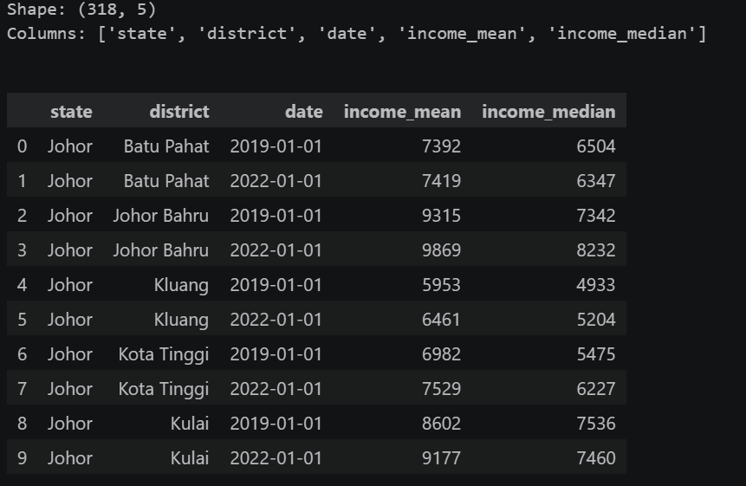
Figure 10: first 10 rows of the dataset
An inspection of the missing value revealed that there were no null values in all five columns. The dataset will include income data of two years of reference, 2019 and 2022, and 16 Malaysian states as indicated in Figure 11.
The list was narrowed down to include only the seven districts in Greater Klang Valley that are under the study. It used aboolean filtering condition to keep the records of W.P. Kuala Lumpur and W.P. Putrajaya in their entirety and only the five Selangor study districts namely, Petaling, Ulu Langat, Sepang, Gombak and Klang using the isin() method. The chosen year of records 2022 was used as a reference year because it is the most recent year that the household income estimates are available. Figures X above indicates that after the filtering, 7 records were generated, one record per study district and income mean values ranged between RM10,278 in Klang to RM13,673 in Sepang.
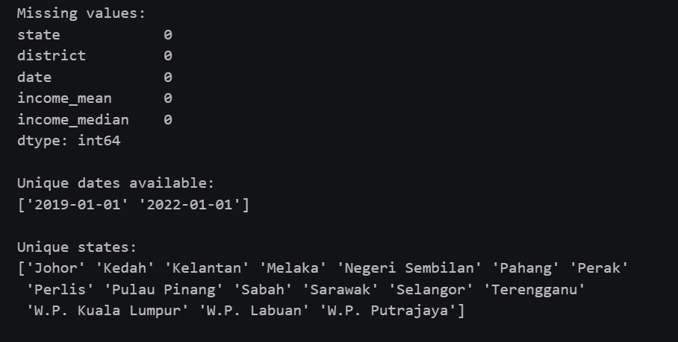
Figure 11: null check, unique dates

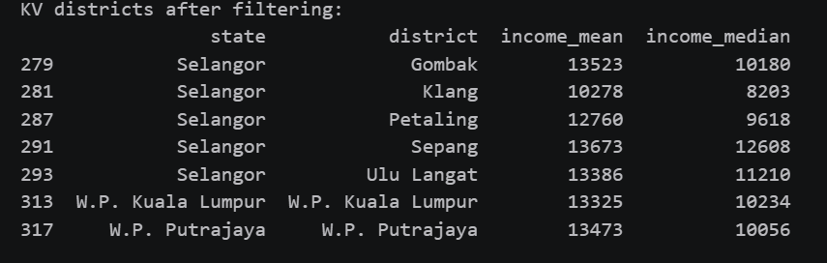
Figure 12: 7 KV districts with income values
The replace() function was then used to apply a district name standardization step to make sure that all five datasets are consistent. The district name Ulu Langat was changed to Hulu Langat, W.P. Kuala Lumpur and W.P. Putrajaya to WP Kuala Lumpur and WP Putrajaya respectively. An ultimate zero check of values verified the zero nulls of all columns as in Figure 13.
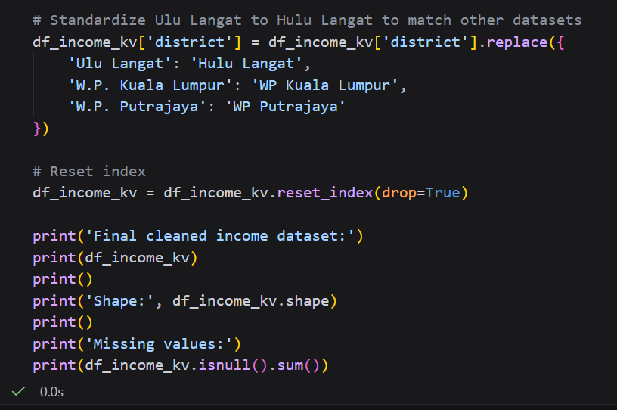
Figure 13: replace district name
The pre-processing, as summarized in Figure 14, narrowed down the raw data of 318 records to 7 district-level records, the years of reference of 2022 being chosen and the names of the districts standardized. The cleaned data were stored as income_kv_clean.csv.
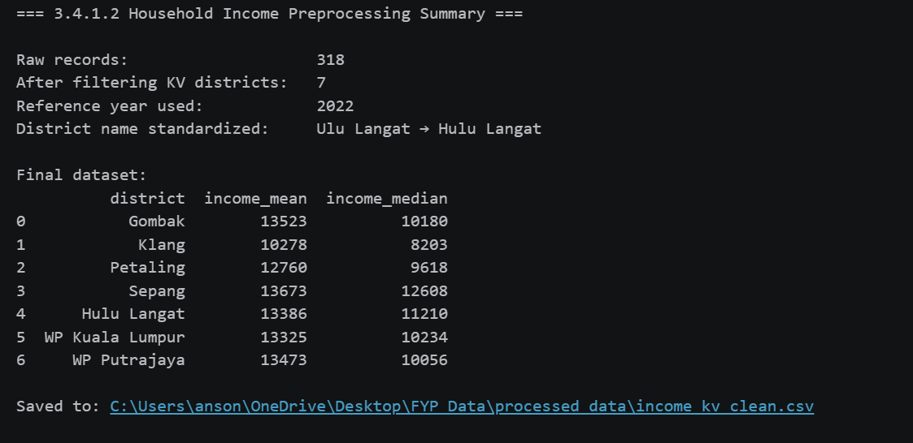
Figure 14: Summary of household income dataset

3.4.1.3 Population Dataset
The Population Dataset was loaded with the help of pd.read_csv. The raw data as indicated in Figure 15 has 319,200 records in 7 columns: state, district, date, sex, age, ethnicity, and population. The dataset includes 5 reference years (2020-2024) and population is divided by sex (both, male, female), age group (19 age groups and overall) and ethnicity (7 categories and overall).
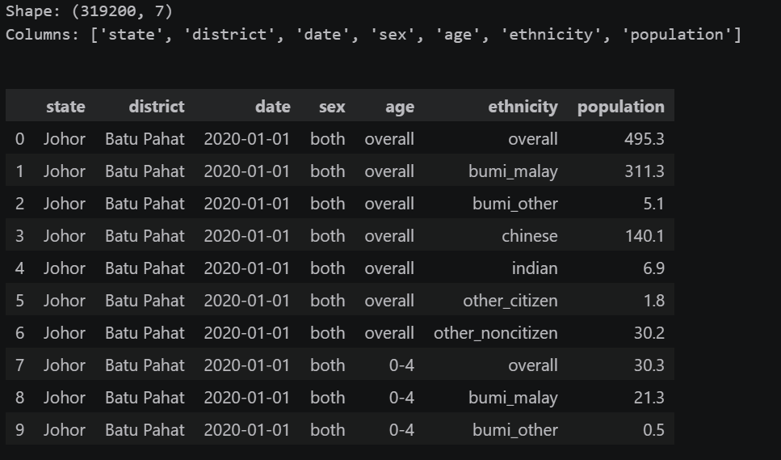
Figure 15: summary data of population dataset
In order to get the overall population figure at the district level, a combined boolean filter was used to only retain records where both sex and age equals overall and ethnicity equals overall. This filter was subsequently merged with the KV state and district scope filter, to leave only W.P. Kuala Lumpur, W.P. Putrajaya and the five Selangor study districts. The filtered dataset as depicted in Figure 16 generated 35 records which depicted 7 districts and 5 annual snapshots.
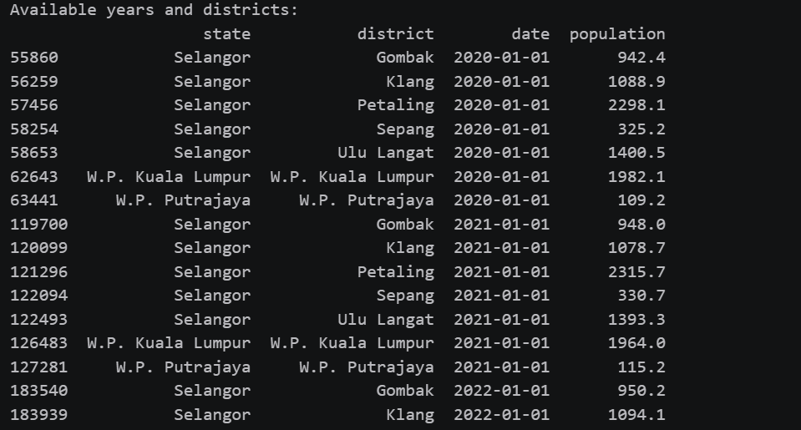
Figure 16: filtered row across years
The most recent full-year population estimate, which is 2023, was chosen, and then the dataset was cut to 7 records. The population values in raw data are in thousands, which is verified by DOSM OpenDOSM data catalogue. A unit conversion was made by multiplying the column of population with 1000 and casting it to integer by using the .astype(int). The population values resulting are between 118,800 in WP Putrajaya and 2,334,700 in Petaling as illustrated in Figure 17.
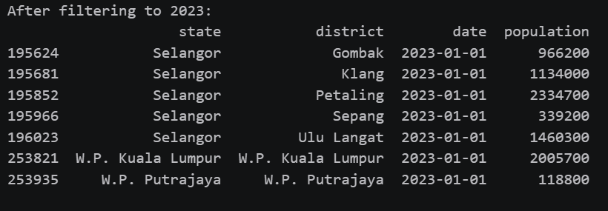
Figure 17: showing 7 districts with actual population values

3.4.1.4 KV Demand Proxies (POI) Dataset
An inspection of a missing value indicated that nine out of the sixteen columns contained very high percentages of missing values with the building column registering a percentage of 30.4% and highway column registering 99.9% as indicated in Figure 18. This is a structural pattern anticipated in OpenStreetMap data, with each POI being tagged with only one primary tag type, such as a restaurant would have a value in the amenity column but would have a null value in all other tag columns like shop, office, leisure, and landuse. As the poi type and category columns already offer a consolidated classification of every POI, the raw OSM tag columns will not add any value to the analysis.
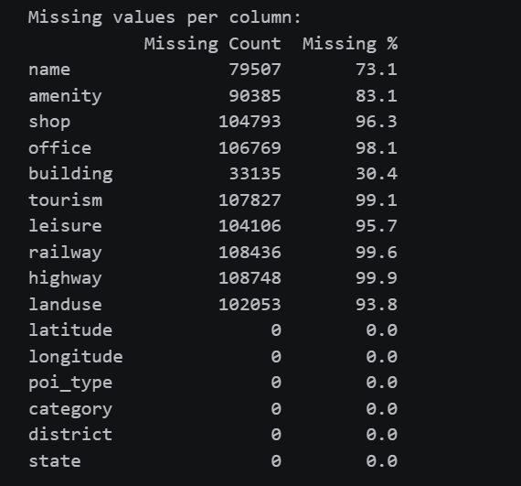
Figure 18: missing value with percentages
An analysis of the cleaned data revealed that all 7 study districts and 11 demand categories were covered as represented in Figure X. The shopping category is most common with 35,910 POIs as compared to work with 30,527 POIs. The maximum number of POI is recorded in WP Kuala Lumpur with 41,256 records, and the minimum number in WP Putrajaya with 783 records which is an indicator of the urban density difference within the study area.
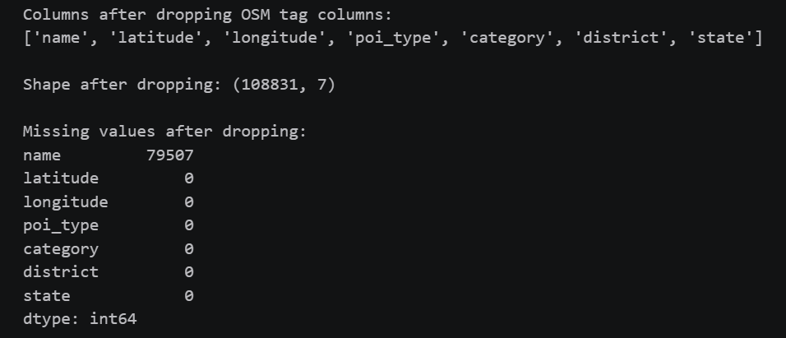
Figure 19: showing category and district distributions
Further cleaning resulted in 46 records under the district label Outside KV, which was POIs that were somewhat outside the defined study area boundaries during the extraction with OSMnx. A filtering condition based on Boolean was applied to eliminate these records and the final dataset was 108,785 records as illustrated in Figure 20.
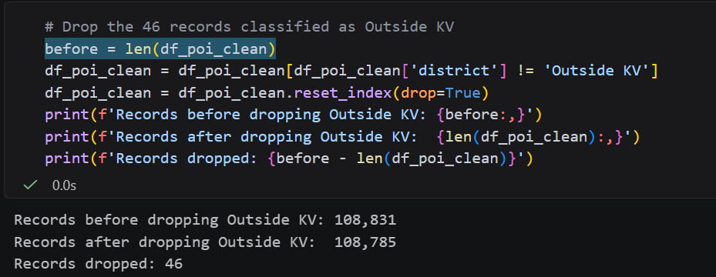
Figure 20: before and after Outside KV removal

3.4.1.5 KV Fused EV Charging Station Dataset
KV Fused EV Charging Station Dataset was read with the help of the pd.read_csv() command. Figure X below illustrates that the raw dataset has 545 records and 23 columns that represent the number of public EV charging stations that were assembled using three sources, i.e., Open Charge Map (OCM) with 288 records, Google Maps Places API with 205 records, and OpenStreetMap (OSM) with 52 records.
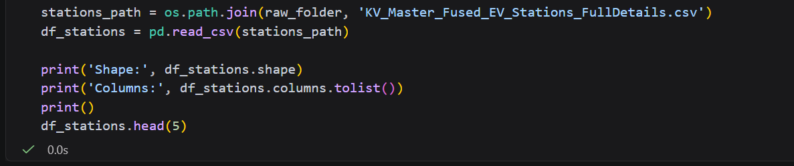
Figure 21: code of first 5 rows of the EV charging station dataset
An investigation into missing values indicated that there was an organized null pattern as depicted in Figure 21. Out of 205 available records retrieved through Google Maps Places API, most of the absent values per column were covered such as station id, usage type, is free, fast charge port, connector type, and most importantly, district and state. The highest overall null rate was in the address2 column at 92.5, other columns such as station name, operator, longitude and latitude, status and source had all records completed in the total 545 records.
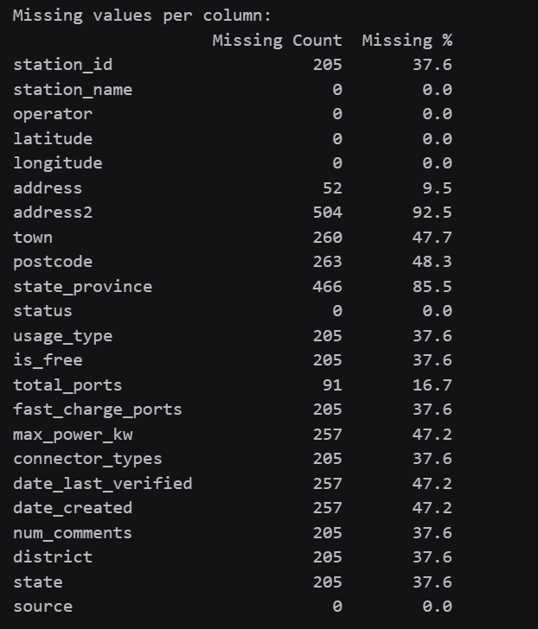
Figure 22: showing missing value table

The source and district distribution analysis also verified that all 205 records with missing district and state values were generated by Google Maps source as indicated in Figure 23, whereas the OCM and OSM records already had valid district assignments.
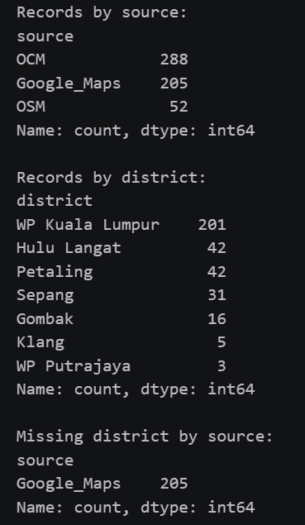
Figure 23: showing source counts and missing district by source
To address the lack of the district values of the 205 Google Maps records, a coordinate-based bounding box function called assign-district () was introduced. This is a two-dimensional function that takes the latitude and longitude as inputs and returns the district and state name of the location given the predefined ranges of coordinates of each of the 7 study districts. A mask of Booleans was used to apply the function to all rows with a null district field. The Sepang bounding box was initially configured to have a maximum latitude of 2.90 which later increases to 3.00 following an investigation that showed that 10 stations between latitudes 2.91 and 2.99 were improperly identified as Unknown. After the correction, the district assignment gave zero Unknown records as indicated in Figure 24.
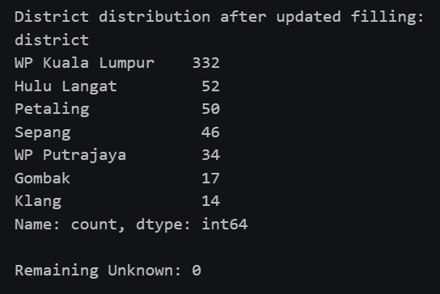
Figure 24: showing updated district with 0 Unknown
A duplicate check done with the coordinates with df.duplicated ( subset=['latitude', 'longitude]) revealed 20 records, of which 10 were duplicate pairs as indicated in Figure 25. When further investigated, all 20 duplicate records were from the OCM source and had the same station names, coordinates, total number of ports, and operator details. These were thus identified to be intra-source duplicate entries in OCM, and not physically different charging points. The identical coordinates were eliminated by keeping the initial appearance of each pair of coordinates with drop_duplicates(keep=first) which dropped 545 to 535 distinct stations.
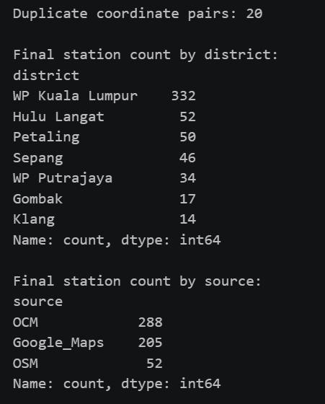
Figure 25: showing 20 duplicated pairs

3.4.2 Data Understanding
In this section, the data understanding analysis of all five clean datasets is presented. Each dataset is characterized by describing its variables, emphasizing important observations, and visualizing to show patterns and distributions that can be of interest to the computation of the Charging Desert Index.

3.4.2.1 JPJ KV EV Car Dataset
The cleansed JPJ KV EV data has 60,063 records and 6 variables. The date reg variable is also a datetime64 that contains the date of registration of each vehicle. The fuel variable is a discrete string that ensures that all the records are electric. KV state is determined by the state variable. year and month variables are integer fields which are based on date reg to facilitate aggregation of time series and year month is period field which is the sum of year and month to provide monthly level forecasting.
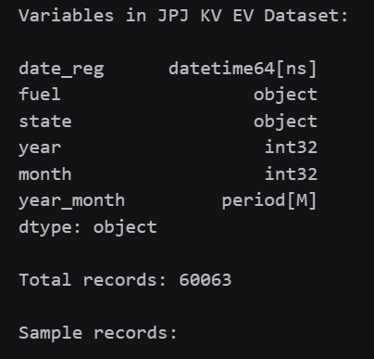
Figure 26: variable and dtype
Figure 27 indicates that there is an apparent and sharp growth trend in EV registrations in the Greater Klang Valley throughout the period. The number of registrations increased to 27,280 in 2025, as compared to 45 in 2020, more than 600 times growth over the five years. This 2026 number of 8,713 is just a partial year. This exponential increase trend confirms the fact that there is an urgency to plan proactive infrastructure, based on the fact that the current charging network was designed to cater to a much lesser number of EVs as compared to the number that will be available in 2030.
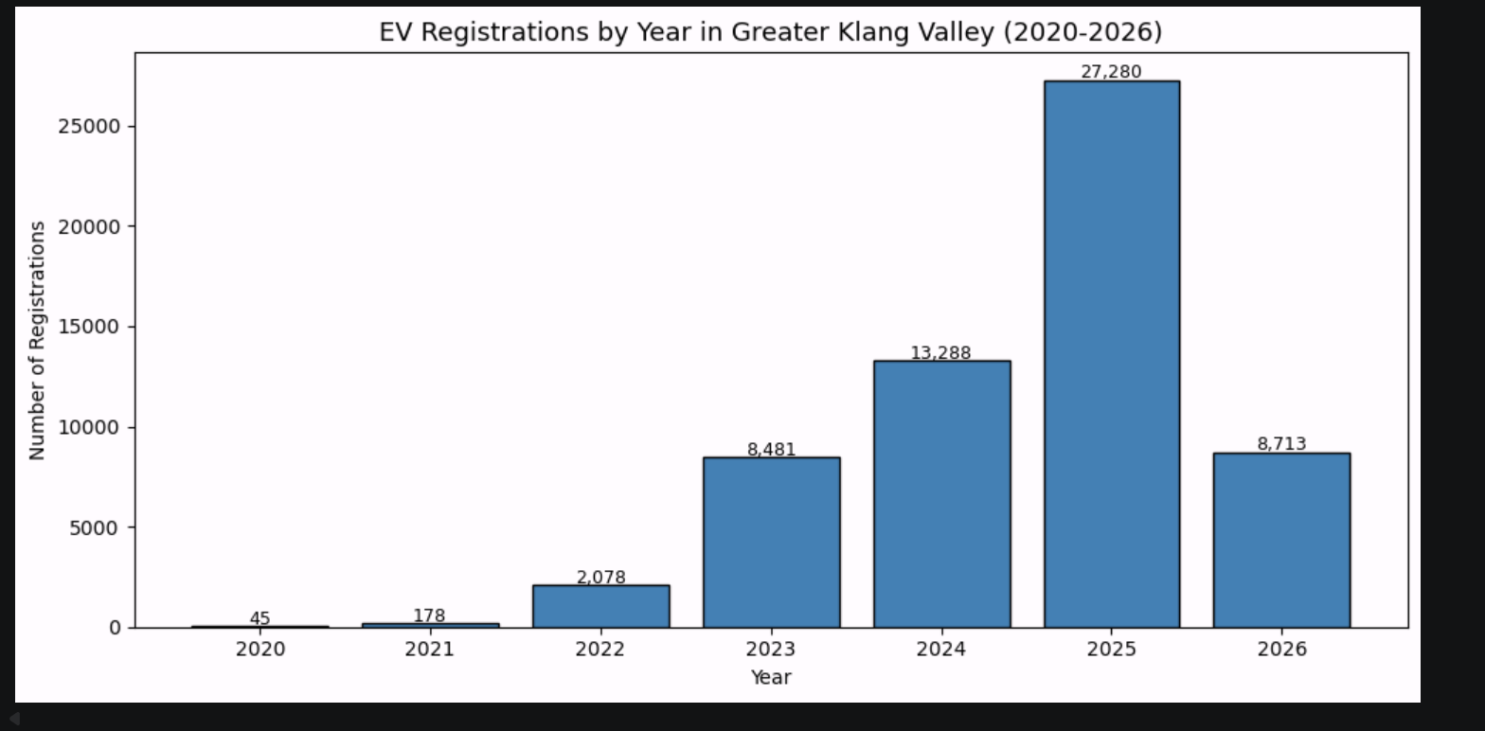
Figure 27: EV registration by year bar chart
As Figure 28 indicates, W.P. Kuala Lumpur has the highest number of registrations of 44,946 (74.8) as opposed to 15,116 in Selangor (25.2) and 1 in W.P. Putrajaya. This concentration represents the urban concentration and higher income picture of the KL residents and is in line with the bias of commercial deployment known in the literature review.
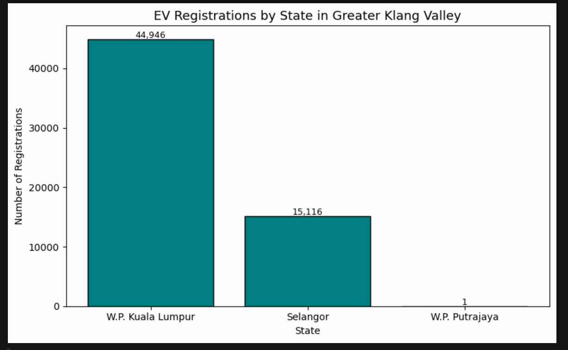
Figure 28: EV registration by state bar chart

3.4.2.2 Household Income Dataset
The cleaned household income data has 7 records that include one per study district and 5 variables. The state and district variables are categorical identifiers. The date variable captures the year in reference to which 2022 is given. These are the income mean and income median variables which are integers of the mean and median of the monthly household income in Malaysian Ringgit respectively.
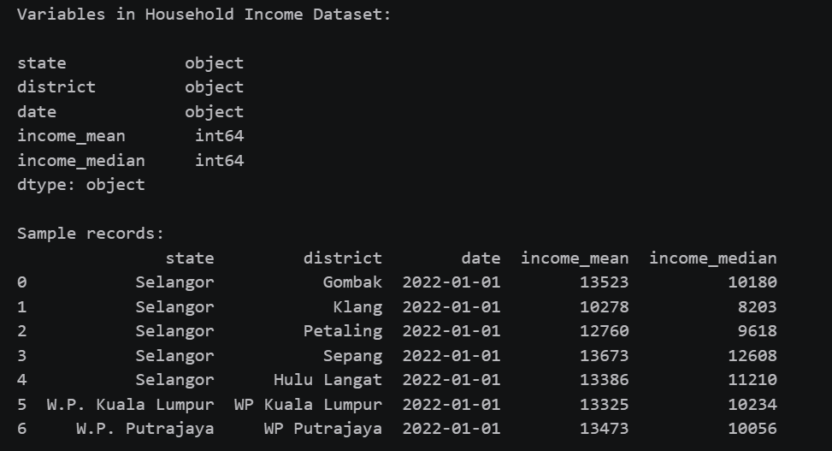
Figure 29: variables and full dataset table
According to Figure 30, there is significant income inequality among the 7 study districts. Klang has the lowest median household income of RM8,203 and Sepang has the highest median household income of RM12,608. This income dispersion is analytically important to the CDI calculation, so the low-median-income districts are weighed with greater equity to make sure infrastructure proposals favor the underrepresented communities, and not further the current bias of commercial deployment to advantaged districts.
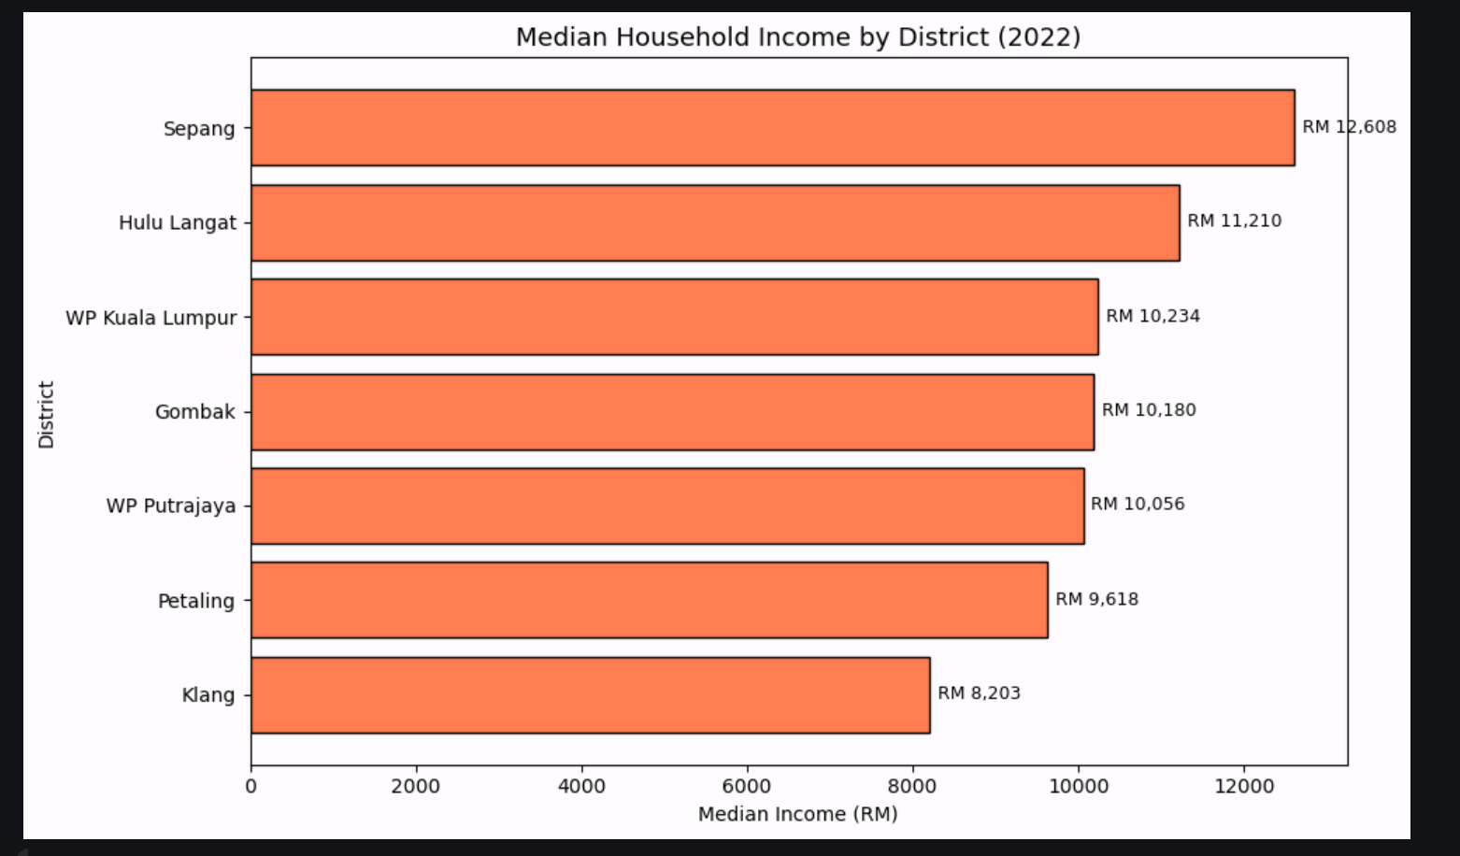
Figure 30: median income by district

3.4.2.3 Population Dataset
The cleaned population data has 7 records in 3 variables. The state and district variables are categorical identifiers, and the population variable is an integer which is the total resident population of each district as of 2023.
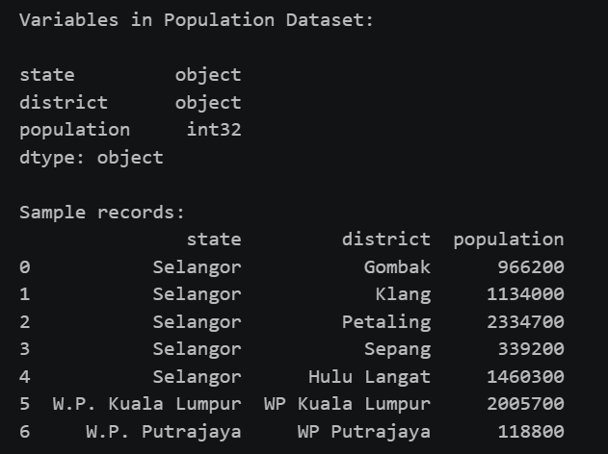
Figure 31: variables and full dataset table

According to Figure 32, the most populated district is Petaling with 2,334,700 residents, then WP Kuala Lumpur with 2,005,700 residents. WP Putrajaya is the least populated with just 118,800 populations. The population variable is a demand weight in the CDI districts with more people have proportionally more latent EV charging demand and thus have more weight in the infrastructure gap analysis.
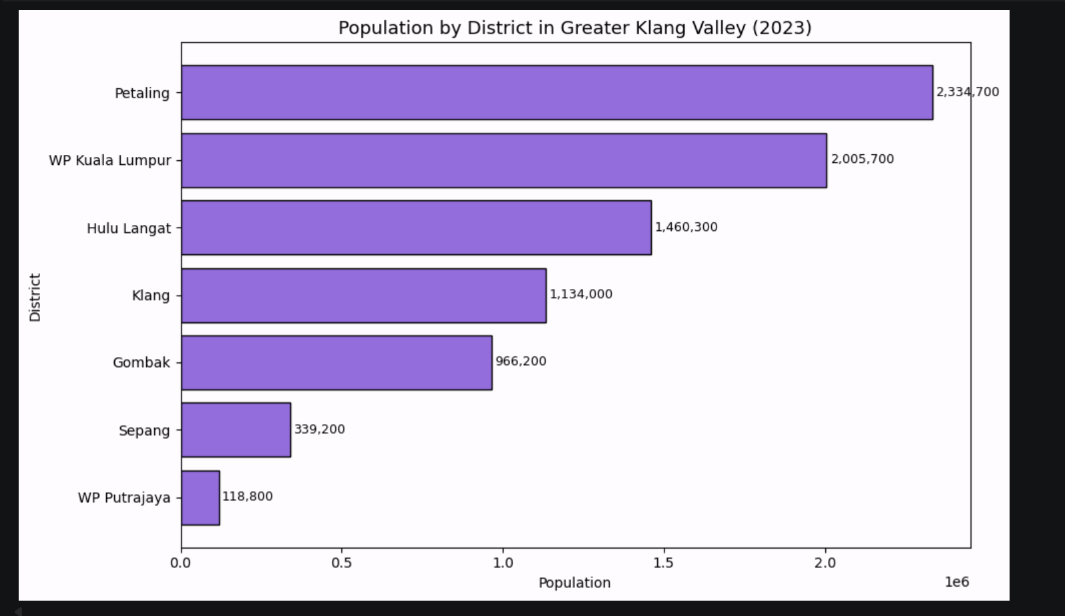
Figure 32: population by district

3.4.2.4 KV Demand Proxies (POI) Dataset
The cleansed POI data has 108,785 entries, and 7 variables. The name variable is a string name of the POI, and any POIs that were not named were termed Unknown. The variables of latitude and longitude are float coordinates that position each POI on the geographic positions. The poi type variable gives a detailed OSM tag taxonomy, whereas category variable classifies POIs into 11 larger demand categories. The district and state variables designate every POI to its administrative area.
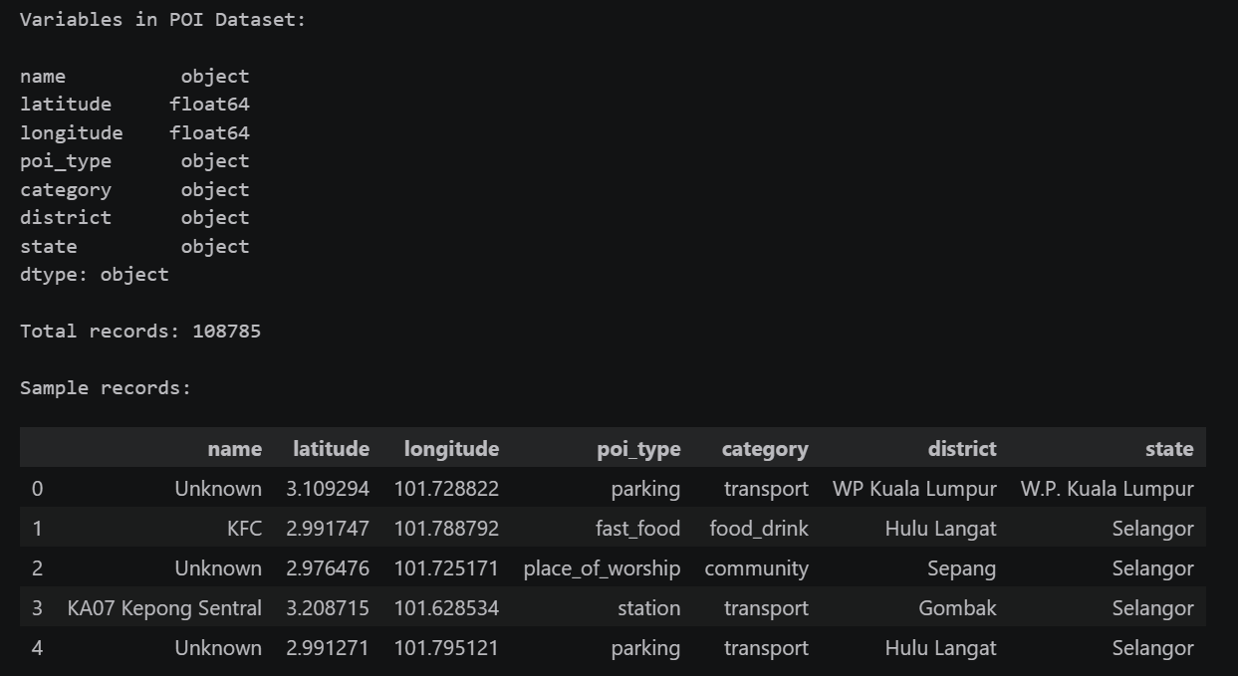
Figure 33: variables, total records and sample rows
Figure 34 indicates that the shopping category has the highest number of 35,910 records, then there are work with 30,527 records and residential with 15,913 records. A combination of these three types covers 75.8 percent of all POIs and is the best suited demand proxies to EV charging since they are areas where vehicles spend prolonged periods of time, forming the dwell time where charging can take place.
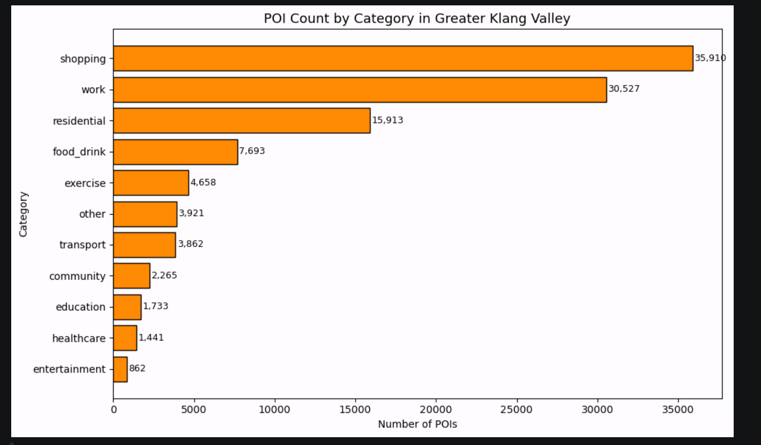
Figure 34: POI count by category

The distribution of the district as illustrated in Figure 35 affirms that the POI density of the WP Kuala Lumpur is the highest with 41,256 records and the lowest at 783 records found in theWP Putrajaya. This indicates the variation in the commercial and residential development density in the study area and has a direct impact on the CDI score of each hexagonal cell the denser the POI in an area, the larger the predicted charging demand.
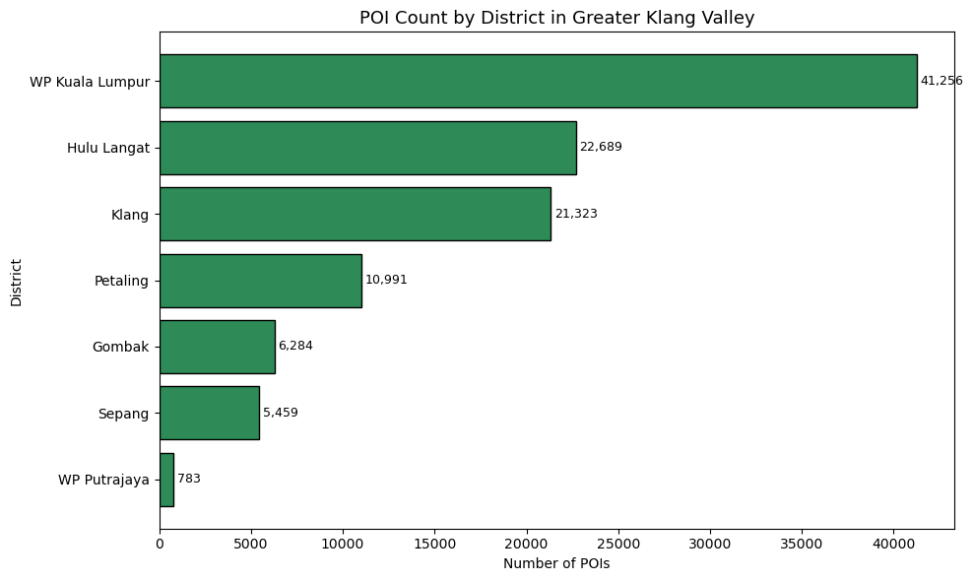
Figure 35: POI count by district

3.4.2.5 KV Fused EV Charging Station Dataset
The EV stations dataset that has been cleaned has 535 records with 14 variables. Each station is identified by the station-id, station-name and operator variables. The variables of latitude and longitude give the exact geographical coordinates. The location is given through the address, town, and postcode variables. Status variable records the operational state of the stations. The charging capacity is measured by the total number of ports and the maximum power: total ports and max powerkw. The district, state, and source variables are used to document the administrative location and source of data of each station.
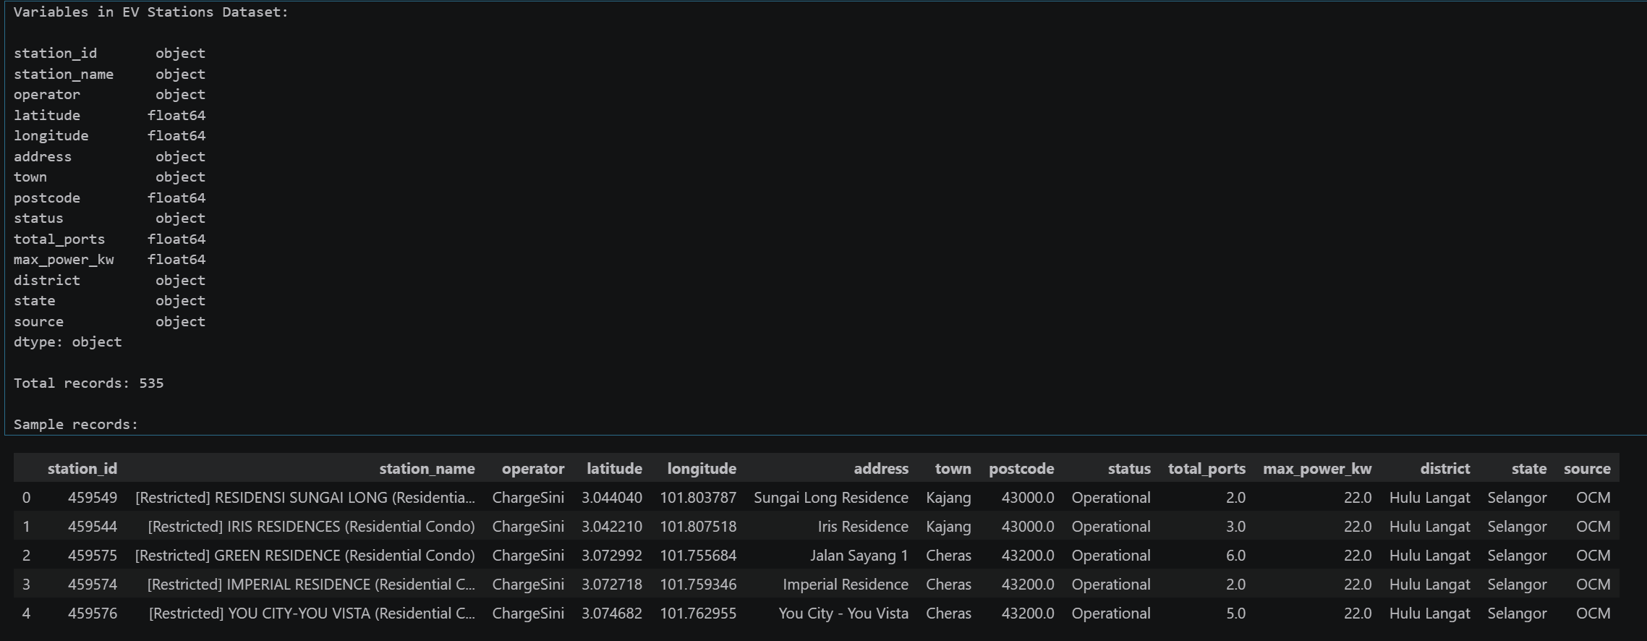
Figure 36: variable, total records and sample rows
The station distribution of the districts as indicated in Figure 37 demonstrates a drastic spatial inequality which is the main driving force behind this study. There are 535 stations in the Greater Klang Valley alone, of which 326 are sponsored by WP Kuala Lumpur, or 60.9%. Comparatively, Klang has a population of 1,134,000 and Gombak has 966,200 yet it has only 14 and 17 stations respectively. This high density in the business center of KL at the disadvantage of the residential areas in the suburbs offers direct empirical support of the Charging Desert phenomenon in the literature review and confirms the equity-weighted optimization strategy of the CDI framework.

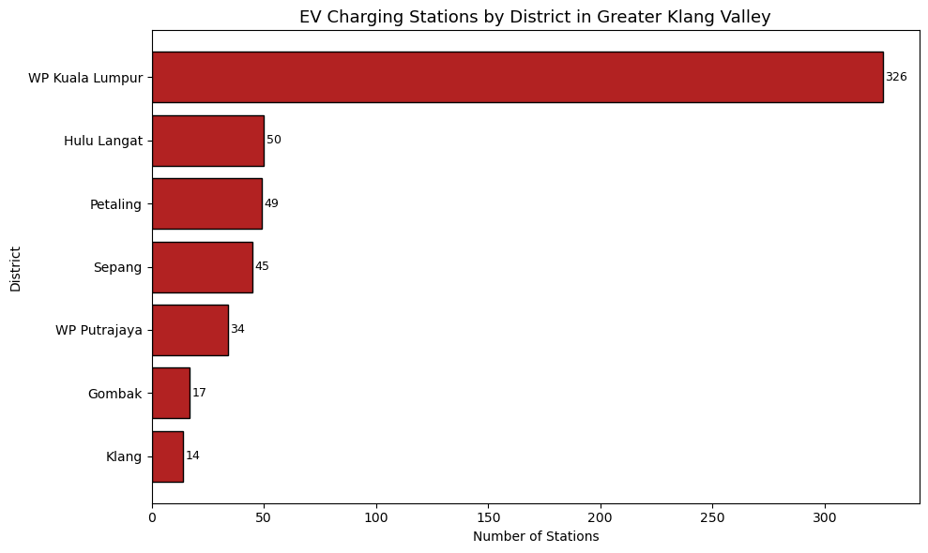
Figure 37: EV station by district
The distribution of the data sources as presented in Figure 38 indicates that OCM had the highest contribution of 288 stations, Google Maps with 205 and OSM with 52. Multi-source fusion approach was required since each platform did not provide full coverage - cross-referencing in the data collection process proved that a substantial part of the stations was only observed on one of the three platforms, which proved the correctness of the choice to merge all three platforms into a single unified dataset.
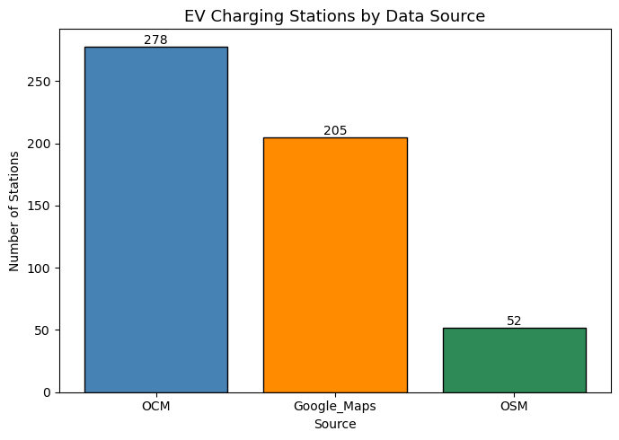
Figure 38: station by source

3.5 Summary
In this chapter, the entire methodology that would be used in this study was outlined in the Cross-Industry Standard Process of Data Mining (CRISP-DM) framework. The chapter started with an introduction to CRISP-DM, explaining why it was chosen among other methodologies like KDD and SEMMA based on the iterative format, practical deployment focus, and applicability to the organizational level of this type of multi-source heterogeneous data projects.
The data collection phase recorded 5 open-source datasets used in the research and they include the JPJ Car Registration Dataset sourced in data.gov.my, the DOSM District Household Income Dataset and the District Population Dataset sourced in OpenDOSM, the OpenStreetMap Point of Interest Demand Proxy Dataset sourced in the OSMnx Python library, and the Fused EV Charging Station The pre-processing phase of data pre-handling took care of various data quality challenges observed in all the five datasets. The JPJ data had to be filtered to electric vehicles, combine seven annual files and redistribute 72502 Rakan Niaga records proportionally to 60,063 records to fix spatial attribution errors, resulting in a final KV EV time-series dataset of 60,063 records. The household income and population datasets were subjected to the 7 study districts and standardization of district name was done so that all datasets shared similarity. There were 9 overlap OSM tag columns and 46 out of bounds records that were eliminated to produce 108,785 clean records in POI dataset. The dataset EV stations were processed to fill the gaps in the district values using the coordinate-based assignment of the bounding box, the imputation of the numerical nulls using the median values, and to eliminate 10 intra-source duplicate pairs, which resulted in 535 distinct stations in the final dataset.
The stage of data insight showed that there were a few observations of analytical importance. The number of EVs registered in the Greater Klang Valley increased four times, to 27,280 in 2025 (compared to 45 in 2020), showing an exponential adoption curve that explains the need to plan proactive infrastructure. The household income analysis showed Klang to be the lowest-income district of RM8,203 median and Sepang to be the highest of RM12,608, to give the equity weighting in the CDI. The POI distribution revealed that the proxies of demand are dominated by shopping and work categories where more than 75 percent of all POIs are represented. Most importantly, the EV station distribution analysis demonstrated that WP Kuala Lumpur alone contains 60.9% of the total number of charging stations in the Greater Klang Valley whereas such districts as Klang and Gombak, which have more than 900,000 people, have less than 20 stations, which directly confirms the Charging Desert phenomenon that drives this research.
The five validated and cleaned datasets generated in this chapter are the full analytic input of the modelling pipeline in the following phase of the project as the Charging Desert Index will be calculated and unsupervised clustering algorithms will be used to determine the best locations to install new EV charging infrastructure in the Greater Klang Valley.

Chapter 4: Conclusion

4.1 Achievement of the First Part of the Project
The initial section of this project has been able to achieve all the preparatory goals to proceed to the modelling and analysis stage. A total of five open-source datasets were identified, collected, pre-processed, and validated to create a clean and integrated analytical base of the Charging Desert Index calculation, as well as time-series demand forecasting pipeline.
The JPJ Car Registration Dataset was combined into 7 annual files and filtered to generate a KV-scoped EV time-series dataset of 60,063 records with the Rakan Niaga spatial attribution issue addressed by a proportional redistribution methodology. The DOSM Household Income and Population datasets were narrowed down to 7 study districts and standardized to be incorporated uniformly. The OpenStreetMap POI Demand Proxy Data set was trimmed down to 108,785 records of 11 types of demand in all 7 districts. The Fused EV Charging Station Dataset was duplicated and spatially enriched to come up with a final dataset of 535 unique stations. The data understanding analysis showed that there was empirical evidence directly supporting the main research problem. The number of EV registrations in the Greater Klang Valley increased more than 600 times in the period between 2020 and 2025, which proves the need to plan infrastructure proactively.
The analysis of distribution of station distribution revealed that WP Kuala Lumpur possesses 60.9 percent of the total number of public charging stations with heavily populated suburban districts like Klang and Gombak having less than 20 stations each, which supports the evidence of Charging Desert phenomenon found in the literature review. These results confirm the topicality and topicality of the equity-based geospatial optimization framework presented in this paper and are consistent with the goals of the project in SDG 10 (Reduced Inequalities) and SDG 11 (Sustainable Cities and Communities).

4.2 Justification of the Investigation and Research
The exploration undertaken in the initial section of this project is an evidence based and comprehensive way of dealing with the research issue. The data fusion approach, integrating JPJ vehicle registration data, DOSM demographic census data, OpenStreetMap geospatial intelligence, and three-platform EV station data, will make sure that the analytical model is based on the most comprehensive publicly available representation of the EV ecosystem of the Greater Klang Valley. All the datasets were chosen with a concise rationale corresponding to a particular role in the Charging Desert Index formula, and therefore, it cannot be said that the decisions concerning the data collection were made based on data availability only.
The literature review determined that the main methodological gap in current EV infrastructure planning research is that it uses past data of charging transactions, which definitionally does not exist in underserved areas. The present research fills in the latter gap by replacing POI density, demographic distributions, and time-series vehicle registration predictions as demand proxies, so that the framework can be applied to the charging desert regions where infrastructure planning is required the most. The CRISP-DM approach offered the systematic iterative approach required to negotiate the multi-source data quality issues faced, especially the Rakan Niaga spatial distortion within the JPJ dataset, which demanded a methodological decision based on reported market data instead of arbitrary imputation.
The results of the data understanding can be understood as the consistency with the trends of spatial inequity recorded in the international literature that makes the context of the Malaysian Klang Valley replicate the patterns of commercial ROI-based deployment bias identified by Ermagun and Tian (2024), Hsu and Fingerman (2021), and Varghese et al. (2024) in their studies. This alignment with the existing literature makes the research design strong and valid and helps to realize that a proposed CDI framework is dealing with a real and well-reported issue, but not a hypothetical one.

4.3 Research Gaps and Areas for Further Exploration
Although the initial stage of this project has developed a sound methodological basis, there are multiple aspects that should be investigated and improved in the next stage of the research.
The first area is that of Rakan Niaga redistribution assumption. The 60 percent proportional redistribution on dealer-registered EVs is according to aggregate national market share information in Ken Research (2021) and Narwat (2023), instead of actual buyer-residence information. Future studies might consider the possibility of JPJ supplementing their data with additional data on dealer registrations and buyer postcodes, which would enable a more accurate attribution on a geographic basis and eliminate the need to rely on this recorded methodological assumption.
The second domain relates to the coordinate-based bounding box method that will be utilized to allocate districts to the 205 Google Maps EV station records. Although after refinement the bounding box method generated zero records that were unassigned, it is a geometric approximation that fails to consider irregular administrative boundaries. A stricter methodology in future work would involve a formal spatial join to official district boundary shapefiles of the Department of Survey and Mapping Malaysia (JUPEM) which would remove the likelihood of cross-boundary misassignment in areas where districts have irregular or curved borders.
The third area is the coverage of the study. The existing framework is confined to the Greater Klang Valley as a pilot area. Although such a geographic limit was needed to ensure data fidelity and computational accuracy the long-term objective is to generate a pipeline that is replicable and can be extended to a nationwide model across all large urban corridors in Malaysia. The next step of the project will assess the ability of the CDI methodology to be generalized to other urban areas with dissimilar density distributions and infrastructure features to form the basis of a prospective nationwide implementation system.

References
Amara-Ouali, Y., Goude, Y., Hamrouche, B., & Bishara, M. (2022). A benchmark of electric vehicle load and occupancy models for day-ahead forecasting on open charging session data. Proceedings of the Thirteenth ACM International Conference on Future Energy Systems, 193–207. https://dl.acm.org/doi/10.1145/3538637.3538850
Andrenacci, N., Ragona, R., & Valenti, G. (2016). A demand-side approach to the optimal deployment of electric vehicle charging stations in metropolitan areas. Applied Energy, 182, 39–46. https://www.researchgate.net/publication/272240037
Beresnev, A. (2022). Hexagonal grids applied to clustering locations in web maps. The International Archives of the Photogrammetry, Remote Sensing and Spatial Information Sciences, XLIII-B4-2022, 435–440. https://isprs-archives.copernicus.org/articles/XLIII-B4-2022/435/2022/
Boeing, G. (2017). OSMnx: New methods for acquiring, constructing, analyzing, and visualizing complex street networks. Computers, Environment and Urban Systems, 65, 126–139. https://joss.theoj.org/papers/10.21105/joss.00215
Box, G. E. P., & Jenkins, G. M. (1976). Time series analysis: Forecasting and control. Holden-Day.
Chapman, P., Clinton, J., Kerber, R., Khabaza, T., Reinartz, T., Shearer, C., & Wirth, R. (2000). CRISP-DM 1.0: Step-by-step data mining guide. CRISP-DM Consortium. https://public.dhe.ibm.com/software/analytics/spss/documentation/modeler/14.2/es/CRISP-DM.pdf
data.gov.my. (2024). Car registration transactions. Road Transport Department (JPJ), Malaysian Open Data Portal. https://data.gov.my/data-catalogue/registration_transactions_car
Davies, D. L., & Bouldin, D. W. (1979). A cluster separation measure. IEEE Transactions on Pattern Analysis and Machine Intelligence, 1(2), 224–227.
Erbaş, M., Kabak, M., Özceylan, E., & Çetinkaya, C. (2018). Optimal siting of electric vehicle charging stations: A GIS-based fuzzy multi-criteria decision analysis. Energy, 163, 1017–1031. https://www.sciencedirect.com/science/article/pii/S0360544218316402
Ermagun, A., & Tian, J. (2024). Charging into inequality: A national study of social, economic, and environment correlates of electric vehicle charging stations. Energy Research & Social Science, 115, 103622. https://www.sciencedirect.com/science/article/abs/pii/S2214629624002135
Ester, M., Kriegel, H. P., Sander, J., & Xu, X. (1996). A density-based algorithm for discovering clusters in large spatial databases with noise. Proceedings of the 2nd International Conference on Knowledge Discovery and Data Mining (KDD-96), 226–231.
Fayyad, U., Piatetsky-Shapiro, G., & Smyth, P. (1996). From data mining to knowledge discovery in databases. AI Magazine, 17(3), 37–54.
Frade, I., Ribeiro, A., Gonçalves, G., & Antunes, A. P. (2011). Optimal location of charging stations for electric vehicles in a neighborhood in Lisbon, Portugal. Transportation Research Record, 2252, 91–98. https://www.researchgate.net/publication/236012949
Franke, T., & Krems, J. F. (2013). Interacting with limited mobility resources: Psychological range levels in electric vehicle use. Transportation Research Part A: Policy and Practice, 48, 109–122. https://www.tu-chemnitz.de/hsw/psychologie/professuren/fgaap/pdf/Franke-Krems_2013_InterRange.pdf
Géron, A. (2019). Hands-on machine learning with Scikit-Learn, Keras, and TensorFlow (2nd ed.). O'Reilly Media. https://www.oreilly.com/library/view/hands-on-machine-learning/9781492032632/
Goodspeed, R. (2015). Smart cities: Moving beyond urban cybernetics to tackle wicked problems. Cambridge Journal of Regions, Economy and Society, 8(1), 61–77. https://www.researchgate.net/publication/269815390
Hsu, C. W., & Fingerman, K. (2021). Public electric vehicle charger access disparities across race and income in California. Transport Policy, 100, 59–67. https://www.sciencedirect.com/science/article/pii/S0967070X20309021
International Energy Agency. (2024). Global EV outlook 2024: Moving towards increased affordability. IEA. https://www.iea.org/reports/global-ev-outlook-2024
Ken Research. (2021). Malaysia used car market share, growth and strategic forecast 2026. https://www.kenresearch.com/industry-reports/malaysia-used-car-market-analysis
Liu, Z., Zhang, Y., & Lv, G. (2018). The application of improved random forest algorithm on the prediction of electric vehicle charging load. Energies, 11(11), 3207. https://www.researchgate.net/publication/329111443
MacQueen, J. (1967). Some methods for classification and analysis of multivariate observations. Proceedings of the 5th Berkeley Symposium on Mathematical Statistics and Probability, 1, 281–297.
Malaysian Green Technology and Climate Change Corporation. (2021). Low carbon mobility blueprint 2021–2030. MGTC. https://www.mgtc.gov.my/what-we-do/low-carbon-mobility-2/low-carbon-mobility-blueprint/
Malaysian Investment Development Authority. (2024). Powering the future: Accelerating Malaysia's EV charging revolution for sustainable mobility. MIDA. https://www.mida.gov.my/powering-the-future-accelerating-malaysias-ev-charging-revolution-for-sustainable-mobility/
Ministry of Economy Malaysia. (2023). National energy transition roadmap (NETR). Government of Malaysia.
Mordor Intelligence. (2025). Malaysia used car market size, share and industry trends 2031. https://www.mordorintelligence.com/industry-reports/malaysia-used-car-market
Narwat, H. (2023). Navigating growth and resilience: Malaysia's used car market trends and strategies. LinkedIn. https://www.linkedin.com/pulse/navigating-growth-resilience-malaysias-used-car-market-harsh-narwat
Neubauer, J., & Wood, E. (2014). The impact of range anxiety and home, workplace, and public charging infrastructure on simulated battery electric vehicle lifetime utility. Journal of Power Sources, 257, 12–20. https://www.sciencedirect.com/science/article/abs/pii/S0378775314000998
Pagany, R., Ramirez Camargo, L., & Dorner, W. (2019). A review of spatial localisation methodologies for the electric vehicle charging infrastructure. International Journal of Sustainable Transportation, 13(7), 433–449. https://www.tandfonline.com/doi/full/10.1080/15568318.2018.1481243
Roy, A., & Law, M. (2022). Examining spatial disparities in electric vehicle charging station placements using machine learning. Sustainable Cities and Society, 83, 103978. https://www.sciencedirect.com/science/article/pii/S2210670722002980
Rousseeuw, P. J. (1987). Silhouettes: A graphical aid to the interpretation and validation of cluster analysis. Journal of Computational and Applied Mathematics, 20, 53–65.
Sahr, K., White, D., & Kimerling, A. J. (2003). Geodesic discrete global grid systems. Cartography and Geographic Information Science, 30(2), 121–134.
Schröer, C., Kruse, F., & Gómez, J. M. (2021). A systematic literature review on applying CRISP-DM process model. Procedia Computer Science, 181, 526–534. https://www.sciencedirect.com/science/article/pii/S1877050921002416
Taylor, S. J., & Letham, B. (2018). Forecasting at scale. The American Statistician, 72(1), 37–45.
Thorndike, R. L. (1953). Who belongs in the family? Psychometrika, 18(4), 267–276.
UNCTAD. (2023). Electric vehicles in Malaysia: Policy implementation challenges. United Nations Conference on Trade and Development. https://unctad.org/system/files/information-document/unda2030d015-malaysia-electric-vehicles_en.pdf
United Nations. (2015). Transforming our world: The 2030 agenda for sustainable development. United Nations. https://sdgs.un.org/goals
Varghese, A. M., Menon, N., & Ermagun, A. (2024). Equitable distribution of electric vehicle charging infrastructure: A systematic review. Renewable and Sustainable Energy Reviews, 206, 114825. https://www.sciencedirect.com/science/article/abs/pii/S1364032124005513
Wirth, R., & Hipp, J. (2000). CRISP-DM: Towards a standard process model for data mining. Proceedings of the 4th International Conference on the Practical Applications of Knowledge Discovery and Data Mining, 29–39. https://www.semanticscholar.org/paper/CRISP-DM:-Towards-a-Standard-Process-Model-for-Data-Wirth-Hipp/48b9293cfd4297f855867ca278f7069abc6a9c24

Appendices

Appendix A: PPF – Title Registration Proposal
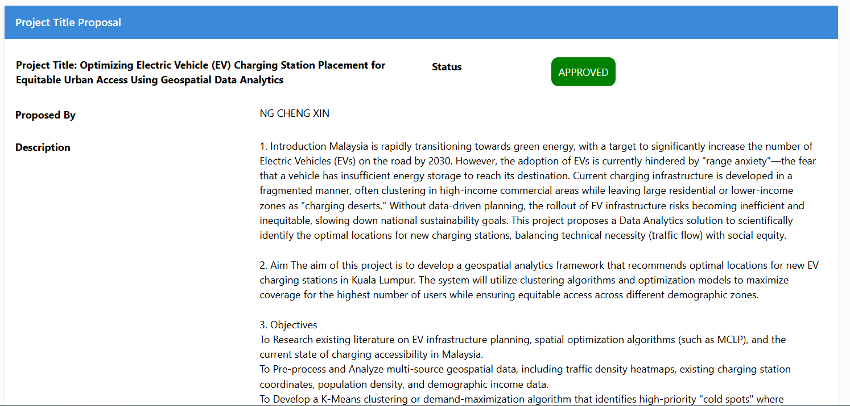



Appendix B: Ethics Forms (Fast Track)
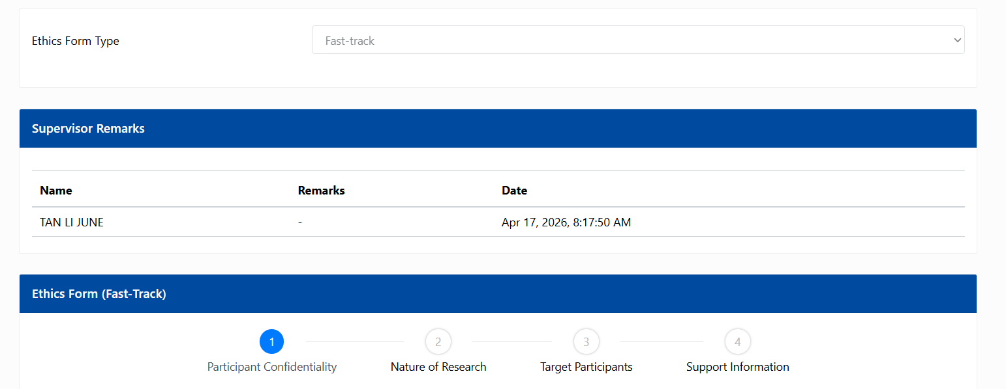



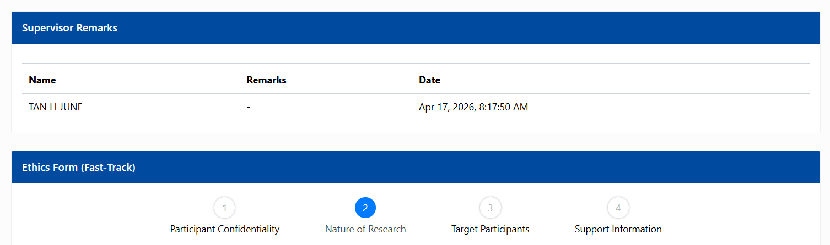
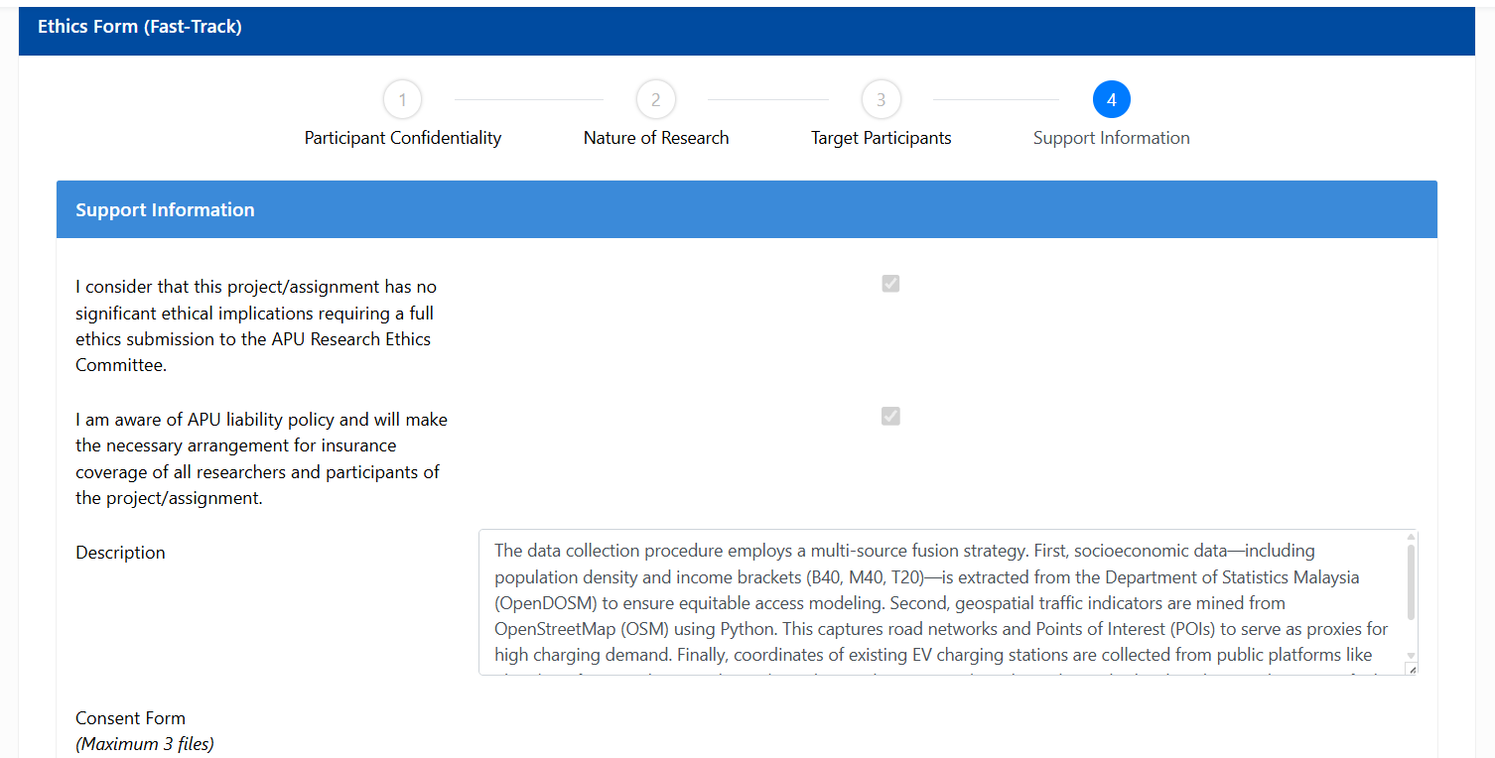

Appendix C: Log Sheets
Log Sheet 1
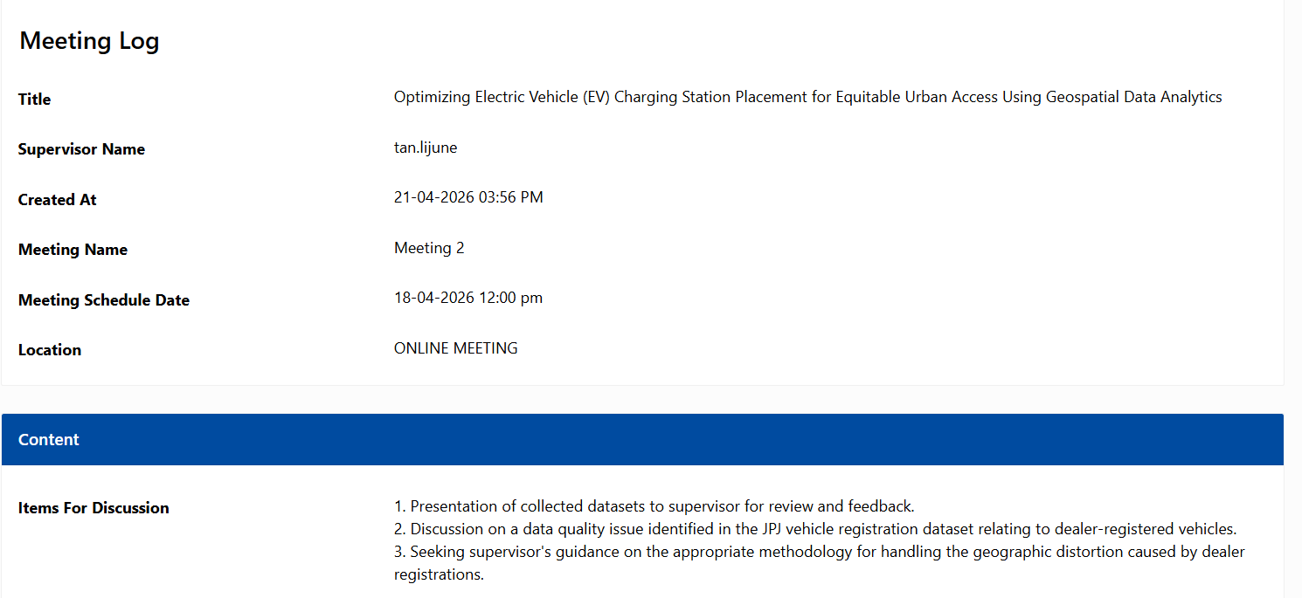


Log Sheet 2


Log Sheet 3


Appendix D: Gantt Chart
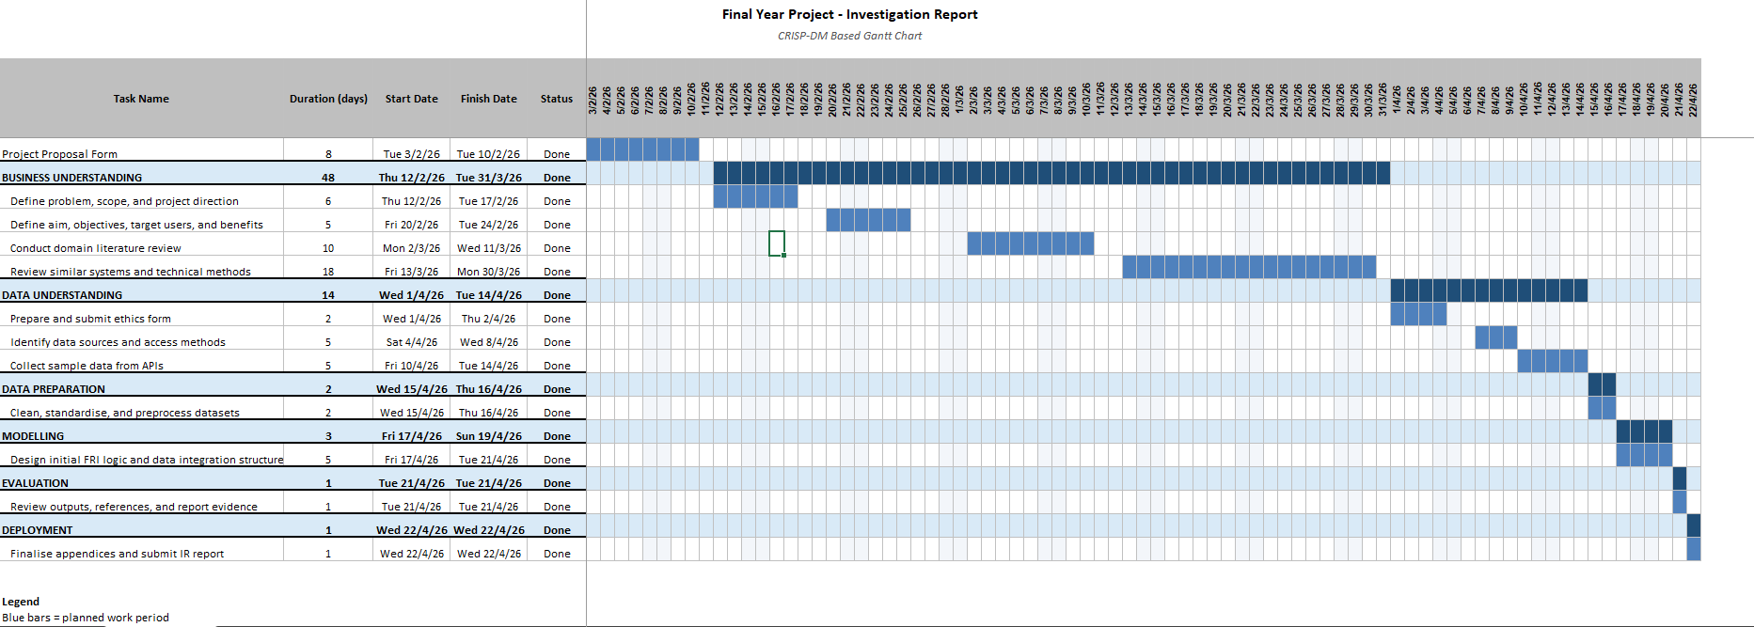
Figure 39: Gantt chart

Appendix F: Turnitin Similarity Report



